The Mental Health and Wellness Center
at Molloy University (MHWC)
Policies and Procedures Handbook
2023

Clinical Mental Health Counseling
Master of Science Program
The School of Education and Human Services

Tyce Nadrich, PhD, LMHC, ACS, NCC
Associate Professor, Chair, Associate Dean and Director
Phone: 516-323-3844
Email: tnadrich@molloy.edu

Kellyanne Brady, PhD, LMHC
Clinic Director, The Mental Health and Wellness Center at Molloy University
Phone: 516-323-3851
Email: KBrady1@Molloy.edu

Table of Contents
INTRODUCTION 3
MISSION STATEMENTS 4
GENERAL GUIDELINES FOR PRACTICUM AND INTERNSHIP AT THE MHWC 5
PRACTICUM AND INTERNSHIP POLICY 6
STUDENT COUNSELOR RIGHTS & RESPONSIBILITIES 7
Code of Ethics 7
Client Confidentiality 7
Professional Appearance and Demeanor 8
Social Media Guidelines 9
Diversity 10
Disposition/Behavior Expectations 10
Professional Competency 10
GENERAL CLINICAL PROCEDURES 13
Timelines and Requirements 13
Session Notes 13
Documentation of Client Contact 14
Payment and Billing 14
SPECIFIC CLINIC PROCEDURES 14
SICK CALLS AND PERSONAL EMERGENCIES 18
WEATHER RELATED CLOSINGS 19
PRACTICUM AND INTERNSHIP INFORMATION 20
APPENDIX A: PRACTICUM AND INTERNSHIP FORMS 21
APPENDIX B: EMAIL CONFIDENTIALITY FORM 35
APPENDIX C: CLINIC FORMS 36
APPENDIX D: DOCUMENTATION PROCEDURES 72

INTRODUCTION

The Policies and Procedures Handbook for Graduate Student Counselors is intended for CMHC graduate student counselors whose practicum or internship site is at the Mental Health and Wellness Center at Molloy University. The purpose of this handbook is to provide student counselors with detailed information for Practicum (MHC 5500) and Internship I and II (MHC 5540, 5560) at the MHWC.

The Master of Science Degree in Clinical Mental Health Counseling at Molloy University requires student counselors to complete supervised practicum and internship experiences. After successful completion of 100 clock-hours for practicum, student counselors complete 600 clock-hours of supervised counseling internship in roles and settings with clients relevant to their specialty area (CACREP 3J, 2016).

The student counselor is required to carefully read this handbook before beginning practicum or internship at the MHWC. Please refer to this handbook throughout your clinical experience to help answer questions and review the appropriate policies and procedures with which it is your responsibility to comply.

MISSION STATEMENTS

Molloy University Mission Statement
Molloy University, an independent, Catholic University rooted in the Dominican tradition of study, spirituality, service and community, is committed to academic excellence with respect for each person. Through transformative education, Molloy promotes a lifelong search for truth and the development of ethical leadership.

The Clinical Mental Health Counseling Program Mission Statement
The Clinical Mental Health Counseling (CMHC) program incorporates Molloy University’s vibrant tradition of “study, spirituality, service, and community” to prepare expertly trained counselors to be highly effective in today’s ever-changing human service field. Through “transformative education,” Molloy University’s mission is to promote a “lifelong search for truth and the development of ethical leadership.” The goal of our CMHC program is to embrace the University’s mission and graduate students who have the professional identity, core knowledge, necessary state-of-the-art practical skills, and multicultural sensitivity to excel as mental health counselors in a variety of professional mental health employment settings.

As a university, Molloy places heavy emphasis on service to the community, especially to those in need. The CMHC program captures the essence of this mission, and it is our intention and hope that the students we prepare for the counseling profession will dedicate much of their energies and activities to helping those in need and serving their communities.

The Mental Health and Wellness Center at Molloy University Mission Statement
In line with the spirit, traditions, and values of Molloy University, as well as the mission of the Clinical Mental Health Counseling program, the Mental Health and Wellness Center (MHWC) seeks to provide individuals in the community with the opportunity for personal growth and wellbeing through the service of the Clinical Mental Health Counseling program’s students, faculty, and staff. Services provided in the clinic are designed to assist individuals in their personal growth, as well as an opportunity for counselors-in-training to transform into expertly-trained clinicians. The MHWC seeks to provide a space for individuals to heal and become empowered through compassion and respect.

GENERAL GUIDELINES FOR PRACTICUM AND INTERNSHIP AT THE MENTAL HEALTH AND WELLNESS CENTER AT MOLLOY UNIVERSITY

There are a few guidelines that apply for both practicum and internship experiences according to Council for Accreditation for Counseling and Related Educational Programs (CACREP) (2016) and New York State Law. Please familiarize yourself with these requirements below:

- Student counselors must be covered by individual professional counseling liability insurance policies while enrolled in practicum and internship. Student counselor’s liability insurance can be purchased through student counselor’s student membership with the American Counseling Association at https://www.counseling.org/.

- Supervision of practicum and internship student counselors includes program-appropriate audio/video recordings and/or live supervision of student counselors’ interactions with clients. As a part of student counselors’ coursework in the practicum and internship courses, student counselors will be required to record audio or video of some of student counselor’s direct clinical hours. Please see student counselor’s syllabus for each course to be clear on the audio/video recording or live supervision requirements.

- Formative and summative evaluations of the student’s counseling performance and ability to integrate and apply knowledge are conducted as part of student counselor’s practicum and internship experience at the MHWC. Student counselors will be required for Practicum and Internship I/II to receive a mid-semester and an end of semester evaluation from their site supervisor at the MHWC as well as end of semester overall feedback from their course instructor regarding their growth and progress. Please see Form PI-1 and PI-2.

- In addition to the development of individual counseling skills, during either the practicum or internship, student counselors must lead or co-lead a counseling or psychoeducational group at the MHWC.

- The MHWC supervisors must be a New York State Licensed Mental Health Counselor (LMHC), Licensed Clinical Psychologist, M.D. with a specialty in psychiatry, Licensed Clinical Social Worker (LCSW), or a Licensed Nurse Practitioner with a specialty in psychiatry. The MHWC supervisors must meet with student counselors one hour a week for individual supervision or one hour a week for triadic supervision (i.e. – one supervisor and two student counselors).

PRACTICUM AND INTERNSHIP POLICY

Clinical responsibilities will be assigned at the discretion of the MHWC Director, Program Director, Clinical Supervisor, and/or the Clinical Coordinator.

Prior to the beginning of a CMHC student’s internship or practicum, each student must meet with the MHWC Director, Program Director, Clinical Supervisor, and/or the Clinical Coordinator to ensure that the student has met the necessary requirements:

Proof of completion of the necessary coursework (from student counselor’s advisor).

Adequate flexibility for the scheduling of clinic clients.

Proof of liability insurance (declarations page and memorandum of insurance). The insurance must be provided prior to entering the program and must be maintained and current throughout the program.

Certificate of completion of Molloy University approved HIPAA training.

Student counselors must complete the required education and/or trainings on the topics below and may be asked to leave clinic for violations of the policies and procedures outlined within these trainings

Maintaining Confidentiality (Section B, p. 6)
https://www.counseling.org/resources/aca-code-of-ethics.pdf

HIPAA Compliance ($25.00)
https://www.hipaastore.com/index.php?main_page=index&cPath=7

Child Abuse Mandated Reporting Course
https://www.nysmandatedreporter.org/TrainingCourses.aspx

Additional places to take the Mandated Reporting Course training can be found at:
http://www.op.nysed.gov/training/caproviders.htm

STUDENT COUNSELOR RIGHTS & RESPONSIBILITIES
- Knowledge of the American Counseling Association (ACA) Code of Ethics as well as the American Mental Health Counselors Association (AMHCA) Code of Ethics
- Compliance with the MHWC Policies and Procedures/Guidelines
- To recognize and be respectful of each client’s cultural, individual, and role differences, including those due to age, gender, race, ethnicity, national origin, religion, sexual orientation, physical ability/disability, language, and socioeconomic status
- To be prepared and organized for each clinical counseling session
- To develop appropriate counseling objectives and therapeutic plan
- To maintain accurate client records and clinical hours records
- To apply information learned in CMHC graduate academic courses to clinical practicum and/or internship
- To engage in topical research to benefit clients and bring new ideas to the practicum or internship
- To attend weekly supervision with your clinical supervisor, seek assistance as needed, and engaging in self-analysis and self-reflection.
- To maintain client confidentiality
- To adhere to HIPAA guidelines and provide proof of the Molloy required HIPAA training
- To adhere to Mandated Reporting guidelines and provide proof of the Molloy approved Child Abuse Mandated Reporting Course
- Respect the MHWC space and remove all personal belongings at the end of each work day.

CODE OF ETHICS
All student counselors will abide by the American Counseling Association (ACA) Code of Ethics as well as the American Mental Health Counselors Association (AMHCA) Code of Ethics.

The entire ACA Code of Ethics and AMHCA Code of Ethics can be found enclosed in student counselor’s CMHC New Graduate Student Handbook.

To obtain a copy of the ACA Code of Ethics, student counselors should refer to: http://www.counseling.org/docs/ethics/2014-aca-code-ofethics.pdf?sfvrsn=4

CLIENT CONFIDENTIALITY
Maintaining client confidentiality at all times is of the utmost importance. Student counselors are expected to adhere to ACA, AMHCA and HIPAA guidelines and must provide proof of the Molloy University approved HIPAA training prior to participating in any observation or clinical practicum experiences. Student counselors must also sign a confidentiality agreement before taking part in the aforementioned activities in or supervised by the MHWC. The confidentiality agreement will be kept on file with all other requisite paperwork for entering clinical practicum or internship.

Information regarding a client is not to be shared with anyone without written permission from the client or guardian/power of attorney. Student counselors must confirm with their site supervisors and/or the MHWC Director that the appropriate permissions have been attained before sharing any information.

No clinical documentation is to be removed from the MHWC. Any documentation or planning materials with identifying client information must be kept at the MHWC and may not be saved or sent electronically other than on the designated hard drive which is the property of the MHWC and CMHC Department. Access to this designated drive is available only at the MHWC. No identifiable client information is to be stored on a student’s personal computer.

Client documentation must be appropriately stored in the client’s electronic medical record (EMR) hosted on TherapyNotes and in the client’s physical chart. Client charts will be stored in the MHWC Client Filing Cabinet and must remained locked at all times. Any documents that contain client information that do not enter into the client chart must be shredded accordingly.

All client conferences and interactions should take place only in a confidential environment and never in a public setting. Clients are not to be discussed in public areas of the MHWC and supervision is to take place in a confidential area, such as the supervisor’s office.

Any violations of client confidentiality will be discussed with your supervisor and will be addressed accordingly.

PROFESSIONAL APPEARANCE AND DEMEANOR
All student counselors are representatives of the MHWC and CMHC Department at Molloy University. As such, they are expected to dress and behave professionally at all times. Clothing should be neat and professional but comfortable.

Interactions with counseling clients at the MHWC, family members and any other staff should be formal and respectful with professional boundaries maintained.

Student counselors are not, under any circumstances, to share their personal contact information or engage in any manner, other than professionally, with current MHWC clients.

Business Casual Dress Guidelines
The following are guidelines for dress and hygiene. They are to be applied equally to all MHWC staff, regardless of gender. The guidelines are meant to be flexible and cultural and religious beliefs that apply to dress and hygiene will always be honored.

Business casual attire is acceptable, employees must appear neat and professional at all times, whether they are scheduled to meet with clients or not. When conducting formal presentations, meeting with administrative officials, or attending other campus meetings, more formal and traditional business attire may be required.

Pants/Shirts
Acceptable | Unacceptable
Khakis, corduroys, slacks, capris | Sweatpants, casual leggings, exercise wear, casual or tattered denim jeans
Skirts that are no shorter than one finger length above the knee | Shorts, Low Rise or Hip Hugger pants or jeans, mini-skirts.
Oxford shirts or Dressy/fitted T-shirts, Polo collar knit | Shirts with writing/logos (other than Oxford shirts with Molloy University logo)
Short-sleeve blouses or shirts | Sporty/unfitted T-shirts or sweatshirts
Turtlenecks, sweaters, knit tops | Crop Tops, Midriffs, spaghetti straps
Blazers or sport coats, or jackets | Exercise wear, beachwear, thermals

Shoes
Acceptable | Unacceptable
Boating or deck shoes | Moccasins, flip flops
Formal Sandals | Shoes that are old, stained, dirty
Casual, low heel, open back shoes (i.e. mules, sling backs)

- Clothing should be professional and clothing that reveals student counselor’s underwear, stomach, lower back, or cleavage is not appropriate.
- Perfume, cologne, and aftershave lotion should be used in moderation, as some individuals may be sensitive to strong fragrances.
- Any clothing, jewelry, or tattoo that conveys a negative statement toward a race, gender, sexual orientation, age, religion, disability, or is otherwise considered harassing or offensive is forbidden.

SOCIAL MEDIA GUIDELINES
Student counselors are presented with unique challenges, some of which are related to social media issues. As the CMHC department and the MHWC continue to refine our social media guidelines, we offer these guidelines as a reference point for our students. We encourage all of our students to bring up any concerns or issues as they may arise with the faculty, one another, and/or site supervisors, when relevant. We will discuss issues of on-line security and privacy, both regarding you and your clients as well as social media in relationship to counselor dispositions during Orientation, Professionalism Night, and during your course of study.

We ask students to please keep in mind:
- Remember that you represent the Molloy CMHC Department. All of your posts, comments and actions on social networks have the ability to impact the reputation of the University as well as other individuals affiliated with the CMHC program.
- Be thoughtful and discerning when engaging on social networking services. Be aware of and write for your audiences. Be aware that your posts can reach anyone and may be misinterpreted or may show up outside of their original context.
- Congruence is important and students are encouraged to present themselves on-line and in person in such a manner that they would be comfortable observing their own counselors behaving away from clinical duties.

DIVERSITY
Molloy University CMHC students and MHWC student counselors respect cultural, individual, and role differences, including those due to age, gender, race, ethnicity, national origin, religion, sexual orientation, physical ability/disability, language, and socioeconomic status.

DISPOSITION/BEHAVIOR EXPECTATIONS
Professional and respectful behavior is expected throughout all facets of this program. Student counselors will be evaluated on non-academic disposition and behavior throughout your time at the clinic and the assessment of your disposition will be shared with your academic adviser.

Areas of evaluation will include, but are not limited to:
- Openness to new ideas
- Flexibility
- Cooperation
- Willingness to accept and use feedback
- Awareness of impact on others
- Ability to accept personal responsibility
- Ability to express feelings effectively and appropriately
- Attention to ethical and legal considerations
- Initiative and motivation
- Appropriate and professional dress

For more information see:
(CMHC Graduate Handbook, Appendix C, p.90)
https://www.molloy.edu/Documents/CMHC_graduate_handbook_2017_18.pdf

PROFESSIONAL COMPETENCY
There may be times when a student counselor behavior is not consistent with the relevant Ethical Standards of the American Counseling Association (ACA) or the American Mental Health Counselors Association (AMHCA). Occasionally, students may also behave in a manner that is inconsistent with the professional behavior of a student counselor.

These situations are called Problems of Professional Competency (PPC). PPCs are viewed quite seriously by the program faculty and warrant faculty involvement and intervention. Counseling faculty members are called upon to be “gate-keepers” of the counseling profession. This means that faculty members have a responsibility not only to our counseling students and their well-being, but to the students/clients they serve currently (as counselors-in-training), as well as to the students/clients they will serve in the future (as professional counselors). PPCs are categorized in to three primary areas (Brown-Rice & Furr, 2013):
- Inadequate academic or clinical skill levels
- Personality and/or psychological unsuitability
- Inappropriate moral character

While there are far too many examples of PPCs to list, some examples may include:
- Inappropriate self-disclosure with students/clients
- Insubordination or unprofessionalism with faculty or site-supervisors
- Unwillingness to examine one’s self or past in order to understand how it is interfering with their counseling or academic performance
- Dishonesty, either directly (i.e. lying), indirectly (i.e. omission, partial disclosure, etc.), fraud (i.e. presenting false credentials), or fabrication (i.e. altering internship hours)

In non-academic related situations, if there is an indication that a student is behaving contrary to the relevant Ethical Standards of the American Counseling Association or the American Mental Health Counselors Association, or in a manner that is inconsistent with professional behavior of a counseling student or practicing counselor, the following process will be followed:

- A faculty member will inform the student about the concern and suggest ways for the student to correct the behavior. The faculty member will review the relevant Ethical Standards of ACA or AMHCA with the student.
- The faculty member will document all the meetings with or pertaining to the student and update the student about continuing concerns and the process that could lead to dismissal.
- The CMHC Program Director will consult with the CMHC faculty in order to assess the seriousness and consistency of the problem.
- If the student is at a fieldwork site, the site supervisor will be contacted by the Field Placement Coordinator for an assessment of the student’s behavior at that site.
- If the behavior does not improve, the CMHC faculty will discuss the student’s behavior including the site supervisor’s assessment and make decisions about the need to determine additional corrective measures, such as a remediation plan, for the student or remove the student from the program.
- If the student is to be continued in the program by some prescribed corrective action or remediation plan, the Program Director will assign two faculty members to present this information to the student. Those two faculty members monitor the behavior of the student through ongoing meetings with the student. The remediation plan will be documented and will include acceptable thresholds and timelines for student improvement.
- If the student is to be recommended for dismissal from the program, the Program Director presents the documentation to the department Chair and the Dean of the School of Education and Human Services
- As indicated in the Student Handbook, the Dean, Chair/Program Director will determine a course of action consistent with University guidelines.
- The student has the right to appeal to the Faculty Committee or the Dean. In either event the decision of the Faculty Committee or Dean is final.

GENERAL CLINIC PROCEDURES

General Guidelines:
Counselor Responsibilities:
- Attain all necessary background information from the initial intake session with the client and/or client's family. If the case is ongoing, student counselor should familiarize themselves with the client's background.
- Keep client documents in a secured location within the MHWC office at all times.
- Ensure proper and secure use of the electronic medical record (EMR)
- Confirm the first appointment date/contact with the assigned supervisor and/or Clinic Director
  - Student counselors are NOT to contact clients unless specifically instructed to do so by their supervisor. In such a case, this contact would take place via a MHWC telephone line. Student counselors are NOT to provide clients with any personal contact information.
- Make an initial appointment to meet with his/her supervisor to discuss the client, initial treatment planning and set up the supervisory meeting schedule.
- Act professionally and ethically at all times and maintain confidentiality. The student counselor should always act in the best interest of the client.
- Prepare yourself to work with each client: Ask questions of the supervisor, research diagnoses and treatment strategies and prepare appropriate materials.
- Be present at every scheduled treatment session. Absences are unacceptable except in the case of extreme emergency. In the event of such an emergency, the student counselor must contact the MHWC and your assigned supervisor. If tardiness or absences continues, the student counselor may be dismissed from the MHWC.
- Follow all timelines set forth by the MHWC.
- Student counselors must obtain prior and specific approval before making referrals to any other professionals.

TIMELINES AND REQUIREMENTS
Student counselors are to adhere to the timelines set forth by the MHWC on treatment plans, progress reports, etc. Failure to adhere to these guidelines will be reflected in the student’s evaluation and may result in a reduction of client assignments and/or dismissal from the MHWC. All paperwork and assignments must be safely filed with the client’s records in the locked cabinet in the clinic. If you have made prior arrangements to provide paperwork or sessions notes to your supervisor or faculty instructor, no identifying information is to be included and should be done through the encrypted platform, TherapyNotes.

Session Notes
Session notes are to be written following each completed counseling session. Notes are to be reviewed by the supervisor after being entered into the EMR. Notes should be submitted to the supervisor no later than 48 hours after the session. If there is a reason that notes cannot be completed and submitted within this timeframe, it is the student’s responsibility to develop an alternative plan with his or her supervisor.

Documentation of Client Contact
All contact between student counselor and client is to be recorded in TherapyNotes in the client’s chart. .

Payment & Billing
Important Facts about the payment and billing process at the MHWC:
- Client payment is to be handled by the CHMC administrative assistant.
- The current fee for all sessions is $30 (60 minutes).
- The payment is due at the time of service at the end of the session.
- The MHWC accepts the following as payment: credit card, cash or personal checks.
- Checks should be made payable to “Molloy University.”
- The clinic is considered an out of network provider for all insurance policies.

Specific Clinic Procedures
Intake Scheduling
- Phone Calls Received
  - Phone calls will screened by the ministrative assistant, clinic director, or clinical supervisor
  - If the phone call is received when no one is available, a message will be taken and emailed to clinic director (or covering individual) – then the procedure below will be followed:
- Voicemail Messages
  - Messages will be received by the clinic director (or covering individual). Messages will either be:
    - Delegated to the administrative assistant or the clinical supervisor to complete the phone screening
    - The phone screening will be completed by the clinic director
- Emails Received
  - Emails will be received by the clinic director (or covering individual) and then:
    - The message will be delegated to the administrative assistant or the clinical supervisor to complete the phone screening
    - The phone screening will be completed by the clinic director
- Walk-ins
  - In the event of a walk-in, there will be a few options:
    - If a counselor or the clinic director is available, a screening can be completed in person
    - If the clinic is busy and no one is available to meet with the prospective client, the individual should be provided with a brochure and the person’s name and number will be taken by the individual who greeted the prospective client
    - The name and number can be given to the clinic director AND administrative assistant by email for follow up
- If the prospective client schedules an appointment, an intake appointment time should be confirmed during the phone call.
  - After the call the client should be entered into TherapyNotes and the appointment should be added using the “Therapy Intake” selection under “type”. The duration should be 60 minutes and costs $30
  - Clients will be sent intake paperwork through the EMR portal
      - Client information form
      - Client History form
      - Client contacts form
      - Adult or minor informed consent form
      - Consent to Release Information form
  - An email confirmation will be sent to the client confirming the name, date, time, and location of the service. This will come from the MHWC@molloy.edu email. The counselor will be BCC’d on the email.
- If the prospective client does not schedule an appointment, due to a wait list, the client will be added to the wait list by the Administrative Assistant
- If for some reason the client requires a referral outside of the clinic, or if there are any other concerns, the Administrative Assistant or Clinic Director will send that information by email to the client
- If there is an emergency with the prospective client, seek supervision immediately with the client on the phone
Intake
- Intake sessions should involve an interview process utilizing the client’s intake documents as a reference. An outline has been developed for the intake interview.
- The counselor should ensure that the client has completed all required documents
- If the intake paperwork is not completed, the client can begin completing the paperwork prior to the session and finish completing after the scheduled session.
- The informed consent document must be completed and signed prior to the initial session
- The consent for recording must be received prior to the first session if recording is to be used during the session
- Use the client checklist to ensure that all documents are received
- At the end of the initial session, follow up sessions should be arranged with client and counselor and entered into TherapyNotes (The client should be provided with a completed appointment reminder form located on the front desk)
Subsequent Sessions
- Follow up sessions will be 60 minutes in length and should be scheduled as a Therapy Session under “type” in TherapyNotes. The cost of follow-up sessions are $30.
- The counselor is responsible for entering the follow-up appointment in TherapyNotes
Cancellations and Missed Appointments
- If the client cancels the session, this should be recorded in TherapyNotes by clicking on the appointment and selecting “cancel appointment” and then “create note” should be selected and the person entering the cancellation can provide an explanation
  - If the appointment is cancelled more than 24 hours in advance, no fee will be charged
  - If not, the person cancelling the appointment should select “Charge Fee” and charge the $30 cancellation fee
  - The client should be notified when he or she calls if the fee is to be charged
- For a missed appointment (No-show) the counselor should select “appointment missed” and then create a brief note and charge the $30 fee
Telehealth Services
- Student Screening and Agreement
  - In order for a student counselor to provide telehealth services at this time, the student agrees to:
    - Provide and utilize a secure, private internet service
    - Utilize a secure personal device that is not shared with others and is password protected
    - Provide a space that is private and professional, free of disruptions
    - Continue engaging in professional behaviors, including, but not limited to:
      - Professional attire
      - Professional demeanor
      - Ensuring appropriate boundaries with clients
    - Complete an online training on conducting telehealth services, including ethics (training link to be provided)
    - Complete a virtual training on update policies and procedures at the Mental Health and Wellness Center at Molloy University
    - Engage in individual supervision (one hour per week) with the assigned Clinical Supervisor utilizing the approved telehealth platform
- Screening and Appointment Scheduling
  - The Clinic Director will conduct a screening to ensure client’s eligibility for telehealth services
  - If client is appropriate based on screening, an appointment will be scheduled; if the client is not appropriate, the client will be informed that they will be contacted to schedule an in-person appointment once the center offices is open
  - The student counselor will be notified of the appointment being scheduled
  - The client will be sent an email with instructions on how to joing the “Patient Portal” through TherapyNotes
  - Once the client has joined, the client will be sent the specific consent forms for telehealth
- The Appointment
  - Prior to the appointment, the clinic director will email the Zoom for Healthcare link to the client
  - The clinic director will initiate the session beginning with the student counselor, then the clinic director will shut off her camera and mic and then allow the client into the virtual room
  - The student counselor will engage in authentication procedures (check date of birth), assess for safety, and obtain a contact telephone number prior to starting the session
  - At the end of the session, the clinic director will ensure that both client and student counselor have left the room
- Payment
  - Clients will be provided with a link to submit a payment by credit card
  - The confirmation email will be sent to the clinic director’s email
  - Once the email is received, the clinic director will post the payment to the client’s account in TherapyNotes
  - The clinic director will compile the payment confirmation to submit to the Office of the Bursar upon returning to campus
  - Credit Card payments will be logged in an Excel document in the shared clinic drive
- Documentation
  - Documentation requirements will remain the same as described in the standing policies and procedures
- Supervision
  - The student will engage in an individual supervision via Zoom for Healthcare for one hour per week
  - The student and clinic director will set up a standing appointment at the time of the student’s agreement to participate in telehealth services
Payment
- The Administrative Assistant, Clinical Supervisor, or Clinic Director will take payment at end of session
  - Intake - $30
  - Follow up - $30
- Counselor will go in to TherapyNotes, post payment, print a receipt for client
  - Open TherapyNotes
  - Select Billing Tab
  - Enter Patient Name
  - Click “enter patient payment” on bottom left
  - Enter correct information and click “save payment”
  - Click “create statement”
  - Select “activity from”
  - Change selection to “current week”
  - Print statement
- Cash or check payment will be placed in the cash box in CMHC Filing Cabinet (key is in key box), place payment in box, and log payment on log sheet in box
- All payments should be appropriately logged in the Payment Tracker document in the CMHC Folder>Billing
Documentation
- Appropriate documentation should be completed as soon as reasonably possible after the time of service, no more than 48 hours (excluding weekends) after session is completed
- After documentation is completed, the Clinical Supervisor will review and approve the documentation in a timely manner
- IMPORTANT: When completing documentation outside of the office on a personal device, please ensure to take every precaution to protect patient information. Client’s names should not be on documents that are stored on personal computers. HIPPA compliance should be ensured at all times.

Emergency Procedures:
- If a client calls for a counselor when the counselor is not here:
  - The crisis situation will be assessed by the clinic director and handled accordingly
  - If the client leaves a message, the message will be forwarded to the counselor, clinical supervisor, and clinic director
    - Communication with the client will be coordinated
    - If anyone will be calling the client from off –site, the number should be blocked using *67 before dialing the number
- Weather emergencies
  - In the event of a campus closing due to weather, the clinic director will communicate with the interns via the school email. Counselors may be required to call their scheduled clients to notify of cancellation and reschedule the appointment. If a message is left for the client, the client should be asked to confirm that he or she received the message by calling the clinic phone. Messages will be checked by the clinic director throughout the day. ( See additional information contained in the weather and emergency policy to follow)
- Checking voicemail and email messages
  - The Administrative Assistant, Clinical Supervisor, and Clinic Director monitor the MHWC@Molloy.edu email during working hours and disseminate emails to counselors as needed

The Molloy University Mental Health and Wellness Center
Policy for Sick Calls and Personal Emergencies

- In the event that a counselor (practicum student/intern) is sick or requires an emergency personal day, the intern must advise the clinic director (or appropriate covering person) of the absence no less than two hours before the scheduled start time
  - The counselor should notify the Clinic Director, Clinical Supervisor, and Administrative Assistant
  - All contact information will be shared at the time of MHWC Orientation
- The counselor may be responsible for contacting clients and rescheduling the appointment
  - If client is reached, the appointment should be rescheduled within the same week
  - If the client cannot be reached, a message should be left for client notifying of the counselor’s absence and need to reschedule
  - The client should be asked to call the clinic number or send the clinic an email at MHWC@molloy.edu to ensure receipt of the message
  - Every effort should be made to reschedule the appointment for the same week
  - If the appointment is not able to be rescheduled for the same week, the appointment should be reschedule for the next available time
- If the counselor is prevented from contacting clients due to the nature of the illness or emergency, he or she must specify that clearly to the clinic director who will contact the clients and complete the rescheduling process
- All contacts with clients must be documented in TherapyNotes

The Mental Health and Wellness Center at Molloy University
Weather Related Closing Procedures

- If Molloy University officially closes for a weather-related incident
  - Clinic Director will contact counselors (interns/practicum students) who are scheduled to be in the MHWC that day
  - Counselors are to log into TherapyNotes and call clients scheduled for that day
  - If client is reached, the appointment should be rescheduled within the same week
  - If the client cannot be reached, a message should be left for client notifying of the closure
  - The client should be asked to call the clinic number or send the clinic an email at MHWC@molloy.edu to ensure receipt of the message
  - The counselor should make every effort to reschedule the appointment within the same week as the original appointment
  - Counselors should confirm cancellations and rescheduled appointments with the Clinic Director via email
- If Molloy University chooses to switch to remote operation:
  - Clinic Director will contact counselors (interns/practicum students) who are scheduled to be in the MHWC that day
  - Counselors are to log into TherapyNotes and call clients scheduled for that day
  - If client is reached, the situation should be discussed with the client and the appointment should be moved to telehealth or rescheduled
  - If the client cannot be reached, a message should be left for client notifying of the options for the appointment
    - The client should be asked to call the clinic number or send the clinic an email at MHWC@molloy.edu to ensure receipt of the message
  - If needed, the counselor should make every effort to reschedule the appointment within the same week as the original appointment
  - Counselors should confirm communication with the client, including cancellations and rescheduled appointments with the Clinic Director via email
Important Information:
-In the event that the Clinic Director is not available, please be sure to be aware of who is covering for the clinic director’s absence
-All calls from personal numbers should be blocked by using *67 before dialing the client’s number
-If there is no confirmation call from the client, the counselor will make a second call at the direction of the clinic director
-All contact and contact attempts should be documented in TherapyNotes

Practicum and Internship Information

Direct & Indirect Services
- Direct service is defined as working with clients face-to-face, in individual, couple, family, or group counseling.
- Indirect service is defined as completing any work that is related to administrative duties, observation, or treatment planning.
- During your practicum experience, 40 of your 100 clock-hours must be direct service.
- During your 600 hour internship, 240 clock-hours must be direct service
Examples of Direct Services | - Individual counseling sessions  - Couples counseling session  - Family counseling session  - Group counseling session  - Psycho-Education  - Career counseling  - Substance abuse counseling  - Tele-mental health services, including crisis intervention and consultation with clients  - Doing an intake  - Psychological assessment  - Co-led therapeutic sessions (individual or group)
Examples of Indirect Services | - Case coordination and consultation  - Observing a counseling session or group session  - Scheduling sessions over the phone  - Planning for your next counseling group  - Giving a presentation at grand rounds  - Academic advising to an undergraduate student  - Case notes  - Treatment planning  - Attending clinical meetings  - Completing insurance paperwork  - On-site supervision  - Self-study (e.g., conferences, webinars, trainings, research for clients) – maximum of 5 hours in Practicum and 15 hours per Internship course  - Class time (1.5 hours of group supervision and .5 hour of instruction per class meeting)

CHECK LIST FOR PRACTICUM/INTERNSHIP AT THE MHWC

____Read the CMHC Practicum and Internship Handbook and the MHWC Policies and Procedures Handbook
____Ensure that your MHWC supervisor meets the requirements as outlined in the handbook and obtain an updated CV from your supervisor
____Complete the Agreement form PI-1 for Internship and submit to Clinical Coordinator via Tevera
____Be sure your Professional Liability insurance policy is current, and submit most up-to-date copy to the Clinical Supervisor

Submit required training certification:

____ HIPAA Training and Compliance

____ Child Abuse Mandated Reporting Course
Other Information:
____ Submit a copy of your mid-semester and end-of-semester evaluation to the Clinical Supervisor (Two weeks prior to due date)
____Submit your time log form to the Clinical Coordinator/Supervisor (Weekly)

Appendix A: Practicum and Internship Forms
**All Practicum and Internship Forms are submitted through Tevera*

FORM PI-1: AGREEMENT FOR PRACTICUM AND INTERSHIP

Molloy University
Clinical Mental Health Counseling Master of Science Program
Agreement for Practicum and Internship
(Signed by site supervisor and student)
Form PI-1

Student Counselor:
Site Name:
Site Supervisor: ______________________________
Supervisor Credentials: _____________________________

Circle one: Practicum (MHC 5500) Internship I (MHC5540) Internship II (MHC 5560)

The Site Supervisor Agrees to: (please initial)

1. Have the appropriate credentials to supervise Clinical Mental Health Counseling Students in New York State as a Licensed Mental Health Counselor (LMHC), Licensed Clinical Psychologist, M.D. with a specialty in psychiatry, Licensed Clinical Social Worker (LCSW), or a registered professional nurse or nurse practitioner with competence in the practice of Mental Health Counseling (i.e., specialized training and/or extensive psychiatric experience). ____
2. Site supervisors have a minimum of a master’s degree, a minimum of two years of pertinent professional experience in the specialty area in which the student is enrolled; knowledge of the program’s expectations, requirements, and evaluation procedures for students; and relevant training in supervision. ____
3. Ensure that the student is provided the opportunity to meet the required indirect and direct hours based on the CMHC Practicum and Internship Handbook. ____
4. Provide a minimum individual or triadic supervision one hour a week for students. ____
5. Supervision of practicum and internship students includes program-appropriate audio/video recordings and/or live supervision of students’ interactions with clients. ____
6. Provide a mid-semester and an end of semester evaluation using Form PI-2 in the Practicum and Internship Handbook. ____
7. In addition to the development of individual counseling skills, during either the practicum or internship, supervisors will provide the student an opportunity to lead or co-lead a counseling or psychoeducational group. ____
8. Ensure the site has a mental health waiver from New York State. ____
9. Ensures that the student has the opportunity to become familiar with a variety of professional activities and resources, including technological resources, during their experience. ____
10. I have received and completed the supervisor training provided by the Clinical Coordinator of the Clinical Mental Health Counseling program at Molloy University. ______
The Student Counselor agrees to: (please initial)
1. Adhere to the policies and procedures for professional personnel (e.g., working hours, dress, and activities) in the setting of my practicum or internship. ____

2. Meet all requirements of Molloy University for practicum or internship in counseling
(professional activities, reports, supervisory meetings) in a timely fashion. ____

3. Maintain professional standards in keeping with the ethical standards of the American
Counseling Association (ACA). ____

4. Cooperate with the site supervisor in my practicum or internship setting. ____

5. Maintain an accurate and complete log of activities using an approved format. ____

6. Submit required reports at appropriate times to my site supervisor, my Molloy University
supervisor, and any other agencies or persons assigned to oversee any clinical work. ____

7. Keep supervisors (site and university) informed of any changes in my work hours and home
addresses and phone numbers. ____

8. Report concerns and problems promptly and completely to site and Molloy University
supervisors so that these may be resolved. ____

9. Attend appropriate professional meetings at site. ____

10. The Student Counselor understands that failure to comply with these requirements shall be cause for immediate termination of the field experience program. ____

The Faculty Professor for the course agrees to (please initial):

- Oversee appropriate audio/video/written or live supervision of student’s interactions with clients in addition to site supervisor. ____
- Provide formative and summative evaluations of students counseling performance and ability to integrate and apply knowledge in practicum and internship, both mid-semester and end of semester via Chalk and Wire and course-specific evaluations. ____
- Oversee that students have completed their forms, hours, and evaluations with their individual sites. ____
- Provide updates and consultation with the Clinical Coordinator when necessary. _____
- Conduct weekly classes that include an average of an hour and a half of group supervision. ____
- Conduct mid-semester and end of semester calls with the site supervisor, as well as refer to Clinical Coordinator if there is a student issue that requires further intervention with the site. _____

The Clinical Coordinator will (please initial):

- Oversee all aspects of the practicum and internship experience and CACREP compliance of Section 3 of the 2016 CACREP standards. ____
- Be available to faculty and site supervisors of practicum and internship for supervision, continuing education, or consultation. _____
- Conduct site visits and maintains university-specific contracts with sites. _____
- Oversee and organize student’s appropriate paperwork and insurance. ____

Student Counselor Contact Information Agency/School
Name: Name:
Address: Address:
City/State: City/State:
Phone: Phone:
Phone: Phone:

Signatures

________________________
Graduate Student Date

________________________
Faculty Professor for Course Date

Site Supervisor* Date

Clinical Coordinator Date
*Site Supervisors please attach a CV or resume to this document

Schedule

The usual times graduate student is expected at the site (days, times):

Molloy College
Clinical Mental Health Counseling Master of Science Program Supervisor’s Evaluation of Student
(To be completed and signed by site supervisor at mid-term and end of semester)
Form PI-2

Name of Student Counselor:

Name of Practicum/Internship Site:

Site Supervisor Name:

Term or Period Covered by this Evaluation:

DIRECTIONS: This evaluation is to be completed by all clinical mental health counseling supervisors at the mid- term and at the end of each semester. The student evaluation form is to be completed collaboratively with the student and reviewed after completion. Final evaluations should be completed the second to last week of the semester. The student is responsible for returning the signed evaluation to their course instructors. Please only select one box and provide specific feedback in each comment section - feel free to write on the back of the paper if you need additional room.
General Supervision

Question | 1-Does not meet standard | 2-Emerging | 3-Meets Standard | Not Applicable or Not Observed
1. Accepts and uses constructive criticism to enhance self- development and
counseling skills.
2. Engages in open, comfortable, and clear communication with peers and
supervisors.
3. Recognizes own competencies and skills and shares these with peers and supervisors.
4. Is on time and
prepared.
5. Is professional in interactions with
clients and staff.
6.Professional dress
Additional Comments:

Professional Identity and Ethics

Question | 1-Does not meet standard | 2-Emerging | 3-Meets Standard | Not Applicable or Not Observed
1. Adheres to professional code of ethics.
2. Demonstrates a personal commitment in developing professional
competencies.
3. Understands role and identity as a counselor within the greater organization.
Additional Comments:

Counseling Theory

Question | 1-Does not meet standard | 2-Emerging | 3-Meets Standard | Not Applicable or Not Observed
1. Is able to incorporate counseling theory into case conceptualization and treatment planning.
2. Is able to apply counseling theories appropriately to individual or group clinical work with
client(s).
Additional Comments:

Helping Relationships

Question | 1-Does not meet standard | 2-Emerging | 3-Meets Standard | Not Applicable or Not Observed
1. Is genuine and congruent with
clients.
2. Consistently demonstrates verbal/non-verbal
attending skills.
3. Uses basic counseling skills (paraphrasing; reflection of content; reflection of feeling; summarizing) appropriately to
establish rapport.
4. Effectively demonstrates confrontation skills.
5. Accurately summarizes and acknowledges clients concerns/goals during and at the end of sessions.
Additional Comments:
Social and Cultural Diversity
Question | 1-Does not meet standard | 2-Emerging | 3-Meets Standard | Not Applicable or Not Observed
1.Awareness of and sensitivity to clients’ cultural identity and its impact on human behavior
2. Attends to cultural factors within counseling and during case
conceptualization.

Additional Comments:

Human Growth and Development

Question | 1-Does not meet standard | 2-Emerging | 3-Meets Standard | Not Applicable or Not Observed
1. Considers the developmental trajectory when conceptualizing and treating clients.
Additional Comments:
Career Counseling
Question | 1-Does not meet standard | 2-Emerging | 3-Meets Standard | Not Applicable or Not Observed
1. Considers and uses career counseling theory and tools when deemed
appropriate.
Additional Comments:
Group Counseling
Question | 1-Does not meet standard | 2-Emerging | 3-Meets Standard | Not Applicable or Not Observed
1. Understands group dynamics and responds effectively.
2. Understands and applies group counseling theory effectively.

Additional Comments:

Psychodiagnostics and Assessment

Question | 1-Does not meet standard | 2-Emerging | 3-Meets Standard | Not Applicable or Not Observed
1. Can interpret tests
appropriately.
2.Can identify cognitions, behaviors, and/or feelings in the client important to making a diagnosis according to the Diagnostic
and Statistical Manual of Mental Disorders, 5th edition.
3. Uses data collected in assessment interviews to develop professional written diagnostic reports.
4. Develops appropriate treatment goals/recommendations based on diagnostic assessments.
Additional Comments:

Research and Program Evaluation
Question | 1-Does not meet standard | 2-Emerging | 3-Meets Standard | Not Applicable or Not Observed
1. Awareness of current research and evidence based practices with the population the
student is serving.
Additional Comments:

Crisis Intervention

Question | 1-Does not meet standard | 2-Emerging | 3-Meets Standard | Not Applicable or Not Observed
1. Uses appropriate theory and skills to address crisis situations.
2. Assesses and responds to suicidality when
indicated.
3. Uses trauma informed care when
appropriate.
Additional Comments:

Mental Health Systems

Question | 1-Does not meet standard | 2-Emerging | 3-Meets Standard | Not Applicable or Not Observed
1. Understands role of counselor in larger
system at site.
2. Demonstrates a willingness and desire to engage in interdisciplinary collaboration.
Additional Comments:

Personal Growth and Understanding
Question | 1-Does not meet standard | 2-Emerging | 3-Meets Standard | Not Applicable or Not Observed
1. Openness to new
ideas.
2. Ability to accept personal
responsibility.
3. Ability to express feelings effectively
and appropriately.
4. Ability to critique and analyze own
taped sessions.
5.Recognition of personal values, experiences, and history and how they
influence counseling
Additional Comments:

Name of Supervisor:

Date Signature of Supervisor:

Name of Student Counselor:

Date Signature of Student Counselor:

My signature indicates that I have read the above evaluation and have discussed the content with my site supervisor. It does not necessarily indicate that I agree with the evaluation in part or in whole.

Student narrative response to evaluation:

Molloy College
Clinical Mental Health Counseling Master of Science Program Student Site Evaluation
(Filled out and signed by student)
Form PI-4

STUDENT EVALUATION OF PRACTICUM/INTERNSHIP SITE

Student in Practicum/Internship:
Internship Site:
Internship Site Supervisor:
Semester and Year: Date: ____

To the Practicum or Intern Student:
Please use this form to evaluate your practicum/internship site. Your response will help the Clinical Coordinator monitor the quality of the provided internship experience. Your honest evaluation is much appreciated. Using the following chart, mark the number that best corresponds with your experience. In the space provided, please add comments to clarify and support your response.

Question | 1-Did not  meet expectations | 2-Inconsistently  met expectations | 3-Consistently  met expectation | Not Applicable
1. The staff was well
qualified and experienced.
2. The facilities for
students were adequate.
3. Orientation to the
agency was adequate.
4. Adequate
opportunities for discussion were provided by supervisor.
5. Staff was supportive
of students.
6.The agency provided
opportunities for obtaining required hours.
7. I was given a
manageable workload at this practicum/internship site.

8. This would be a
good site for other students in the future.
9. I was given
adequate supervision.
10. I would
recommend this site to other students.

Qualitative narrative of clinical experience:

Appendix B: Email Confidentiality Form
Mental Health and Wellness Center 30 Hempstead Avenue
Suite 248
Rockville Centre, NY 11571-5002
Tel: (516) 323-3854
Fax: (516) 323-4866

Email Confidentiality
Regarding Email: MHWC@Molloy.edu
This form is meant to protect the confidentiality of client information and clients who correspond with student counselors using the shared email at the Mental Health and Wellness Center (MHWC@Molloy.edu). The content of the emails are confidential and intended for the recipient and sender specified in message only. It is strictly forbidden to share any part of the messages with any third party, without a written consent of the recipient and sender. If a message is viewed by mistake, please notify the appropriate student counselor and supervisor.
Senders (student counselors) will indicate who the email is intended for using their initials in the subject header. (I.e., Appointment Confirmation (TE).)
Student Counselor:_____________________________________________________________
Student Counselor Signature: _____________________________________Date:____________
Supervisor:____________________________________________________________________
Supervisor Signature:____________________________________________Date:____________

Appendix C: Clinic Forms
*All clinic forms are digitally located in the TherapyNotes Library*

Mental Health and Wellness Center 30 Hempstead Avenue
Suite 248
Rockville Centre, NY 11571-5002
Tel: (516) 323-3854
Fax: (516) 323-4866

INFORMED CONSENT TO TREATMENT FOR COUNSELING SERVICES (ADULT)

Welcome to The Molloy College Mental Health and Wellness Center (MHWC). Our goal is to provide a safe and welcoming space to help you meet your goals for wellness and success. We are excited to begin this journey with you.

This document contains important information about our professional counseling services, policies, and procedures. Please read carefully, and if have any questions, please do not hesitate to ask.

MOLLOY COLLEGE MISSION STATEMENT
Molloy College, an independent, Catholic college rooted in the Dominican tradition of study, spirituality, service and community, is committed to academic excellence with respect for each person. Through transformative education, Molloy promotes a lifelong search for truth and the development of ethical leadership.

COUNSELING SERVICES
The Service. The Molloy College Mental Health and Wellness Center (MHWC) provides counseling services as well as consultation and referral services. Counseling varies depending on the style of the counselor and/or student counselor, and depending on the particular concerns that are brought forward. To ensure that you get the most out of your counseling experience, you will have to work actively on your concerns both during and outside of your sessions.

Risks and Benefits. Counseling has both its risks and its benefits. The counseling process may include coming face-to-face with personal challenges and difficulties, which can elicit uncomfortable feelings such as sadness, guilt, anger, fear, frustration, loneliness, and helplessness. However, counseling has been shown to have many benefits for people: it can often lead to better interpersonal relationships, improved academic performance and coping strategies, solutions to specific problems, and reduced feelings of distress. However, there are no guarantees of what your outcome will be.

Treatment Plan. Counseling can be an effective intervention with many issues. Your initial session will consist of information gathering in order to define your concerns, of developing a treatment plan, and of determining whether the MHWC meets your needs. Your progress will be assessed by your student counselor on an ongoing basis. Ultimately, however, whether or not you decide to remain in counseling after the initial session is your choice.

Session Limits. In order to allow a greater number of people to access services, the MHWC sets session limits dictated by the scope and severity of the concerns.

Alternatives. In order to best serve the needs of all who come to the MHWC, those who require longer-term counseling, more intensive support, or who require some other mental health expertise not offered through the MHWC will be referred to another provider.

Appointments. Initial intake sessions are 60 minutes in length. Individual appointments are 45 minutes in length. Since appointments are reserved ahead of time, please provide the MHWC with at least 24 hours’ notice if you need to cancel or reschedule your appointment. By providing us with this notice, this allows us to open up the hour to another person. If for any reason, multiple consecutive appointments are missed without notice, the MHWC may have to close your file.

PAYMENT
Fees. The fee for the initial intake session is $30. The fee for subsequent counseling sessions is $20. The payment is due at the time of service at the time of the session. The MHWC accepts payment in the form of cash or personal checks. Checks should be made payable to Molloy College. In the event of a returned check, the client will be notified and the client should make every effort to pay for the session as soon as possible.

Cancellation: The MHWC has a 24-hour cancellation policy. Please be courteous of our time and the time of others- if you cannot keep the appointment, please notify the MHWC as soon as possible. Failure to cancel or reschedule within 24 hours of your appointment will result in a $20 office charge to be paid at the next visit. Multiple no-shows to appointments may result in the forfeiture of services provided by the MHWC.

Please note: The clinic is considered an out of network provider for all insurance policies.

I have read and understand the payment policies noted above: ______________ (Initial)

COMMUNICATION
Email. E-mail is NOT a confidential form of communication, and such correspondence is typically limited to scheduling services. Additionally, clients should be aware that the MHWC may not always have immediate access to nor monitor their email communication on a daily basis.

In Case of Emergency. The clinic hours are limited during the week and may be shorter in the summer. For more information please refer to our website at: https://www.molloy.edu/academics/graduate-programs/master-of-science-in-clinical-mental-health-counseling

The clinic provides phone coverage during working hours, but you may not be able to reach your student counselor who may be in class or seeing other clients. Your student counselor will make every effort to return your call as soon as possible. If you are difficult to reach, please provide us with times you might be available. If you cannot reach us in the event of an emergency you should contact your physician or other community resources directly.

During evenings, weekends, or holidays, you should contact or 911 if you are having an emergency. You may also contact the 24- hour Long Island Crisis Intervention Hotline at (516) 679-1111.

SUMMARY OF STAFF TRAINING
The MHWC is composed of Practicum or Internship student counselors who are currently pursuing graduate degrees in Clinical Mental Health Counseling at Molloy College. The counseling you receive may be from a student counselor under the supervision of a clinical supervisor. All student counselors- in-training will inform you of their trainee status.

As a training site, the MHWC may use audio recordings of sessions for the student counselor’s supervision. With this being said, however, you may request that the recording be stopped at any point and/or that the recording be erased at any point. Please note that this will not impact the availability of services to you. In the appropriate space below, please initial your preference of recording:

Please initial for consent:

_____ I agree to audio/video recording

_____ I do not agree to video/audio recording

CONFIDENTIALITY
Privileged Communication. New York State law protects the confidentiality of the relationships between certain mental health professionals and their clients. Communications (verbal or otherwise) made by you to your counselor (other than by email) are intended to be confidential, and those which occur in the context of counseling are generally considered to be “privileged.”

Exceptions to confidentiality. There are certain circumstances that require or allow mental health professionals to break confidentiality without consent, if necessary.

These include:
- If it is deemed necessary to prevent clear and immediate danger to self or others, the MHWC may need to notify responsible individuals for your protection and/or the protection of others.
- If there is suspected abuse or neglect of a minor or elder, the MHWC is required by law to file a report with Child Protective Services (CPS).
- Under the New York State SAFE Act of 2013 (Secure Ammunition and Firearms Enforcement Act), mental health providers are required to report alerts to the Nassau County Department of Health Services, who, thereafter, must report the alert to the NYS Division of Criminal Justice Services (DCJS) if a person is likely to engage in conduct that will result in serious harm to self or others. This law may also prevent impacted people from obtaining a gun permit and may remove firearms from their possession in order to protect the identified person or others.
- If records are subpoenaed directly by a court.
- If in the event of a serious concern or emergency, information may be shared with necessary campus personnel.
- If a written consent form has been signed by you, which would then lead to such clinical information being revealed only in accordance with the terms of the consent.

CLIENT RIGHTS AND RESPONSIBLITIES
Client Rights. The client has the right to:
- Review the credentials of the MHWC, terminate counseling at any time, and receive referral options.
- Have any personal information revealed in counseling treated in a confidential manner, and be informed of any limitations of confidentiality in the counseling relationship.
- Ask questions about counseling techniques, benefits and risks, and participate in setting counseling goals and evaluating progress toward attaining them.
- Access treatment records.

Client Responsibilities. Clients are expected to:
- Keep appointments (client cases may be closed if “no-shows” occur).
- Arrive on time for sessions.
- Cancel at least 24 hours in advance (if possible).
- Make session payments at the time of service.
- Participate actively in the therapy process.
- Terminate your counseling relationship before entering into counseling with another counselor at this facility or at other facilities.

ETHICAL CONDUCT AND PROFESSIONAL STANDARDS
If you have concerns about your treatment, you are encouraged to discuss them with your counselor. If you have concerns about you counselor, you may discuss them with the Clinic Director of the MHWC.

Clinic Director Contact Information:
Kellyanne Brady, LMHC, NCC
Email: KBrady1@molloy.edu
Phone: 516.323.3851

MENTAL HEALTH AND WELLNESS CENTER EFFECTIVENESS
At the end of counseling, you may be asked to complete a Client Satisfaction Survey. Completion of this survey is not mandatory. This survey will be used to improve services for future students. This data may also be used for research purposes to demonstrate MHWC effectiveness. Your confidentiality will be completely ensured.

INFORMED CONSENT
I have read the information provided above and have had the opportunity to discuss all my questions and concerns about receiving services at the Molloy College Mental Health and Wellness Center (MHWC). I understand the nature of the treatment and its associated risks, benefits, and alternatives to this treatment. I have not been guaranteed that the counseling services I receive will have certain results. I have the right to make decisions about my health care, to refuse health care, and to revoke this consent at any time except to the extent services have already been provided. I understand that trainees will be involved in my treatment. I also understand the limitations of services and the exceptions to confidentiality. I consent to receiving counseling services at the Molloy College Mental Health and Wellness Center (MHWC) in accordance with the above services, policies, and procedures.

Your counselor will review this with you and will also sign. Should you choose to exercise your right to refuse to sign this consent form, we will be unable to provide the requested services.

My signature below indicates that I have given my full and informed consent to receive counseling services at the Molloy College Mental Health and Wellness Center.

_______________________________ ______________________________ ____________
Client name (please print) Signature Date

_______________________________ ______________________________ ____________
Counselor name (please print) Signature Date

A COPY OF THE SIGNED CONSENT FORM SHOULD BE PROVIDED TO THE CLIENT AT THE END OF THE INTAKE SESSION. THE ORIGINAL WILL BE PLACED IN CLIENT’S CHART.

Mental Health and Wellness Center 30 Hempstead Avenue
Suite 248
Rockville Centre, NY 11571-5002
Tel: (516) 323-3854
Fax: (516) 323-4866

Consent for Audio and Video Recording (Adult and Minor)
SUMMARY OF STAFF TRAINING
The MHWC is composed of Practicum or Internship student counselors who are currently pursuing graduate degrees in Clinical Mental Health Counseling at Molloy College. The counseling you receive may be from a student counselor under the supervision of a clinical supervisor. All student counselors- in-training will inform you of their trainee status.

As a training site, the MHWC may use audio recordings of sessions for the student counselor’s supervision. With this being said, however, you may request that the recording be stopped at any point and/or that the recording be erased at any point. Please note that this will not impact the availability of services to you. In the appropriate space below, please initial your preference of recording:

_____ I agree to video and audio recording
_____ I do not agree to recording

_______________________________ ______________________________ ____________
Client name (please print) Signature Date

If client is a minor (under the age of 18):
_______________________________ ______________________________ ____________
Parent/Guardian name (please print) Signature Date

_______________________________ ______________________________ ____________
Counselor name (please print) Signature Date

Mental Health and Wellness Center 30 Hempstead Avenue
Suite 248
Rockville Centre, NY 11571-5002
Tel: (516) 323-3854
Fax: (516) 323-4866

CONSENT TO RELEASE INFORMATION (ADULT)

I, ____________________________, Date of birth: ___/___/___, understand that the purpose of this release is to assist with my treatment by improving communication between professional service providers or agencies and the important individual(s) in my life.

To further this goal, I authorize The Molloy College Mental Health and Wellness to release the below-specified information regarding me to the individual(s) listed below, and to receive information from them in any format, including by telephone. I have been informed of the risks to privacy by the use of electronic means of information transfer, and I accept these.

The information that is allowed to be disclosed should be marked with a ✔ in the spaces below, and any information that is not allowed to be released should have a line drawn through it:
___ Name of my student counselor
___ Name(s) of counseling center and location
___ Diagnoses
___ Prognoses
___ Treatment plan
___ Scheduled appointments and attendance
___ Progress notes
___ Compliance with treatment
___ Discharge Plans
___ Treatment summary
___ Psychological or other evaluations
___ Medications
___ Other: ____________________________

The checked items on the above list are to be disclosed to these persons, who have the indicated relationship to me:

_______________________________________ _________________________________________
Name of person Relationship

_______________________________________ _________________________________________
Name of person Relationship

_______________________________________ _________________________________________
Name of person Relationship

I understand that I may revoke this release at any time, except to the extent that it has already been acted upon.

This release will expire:
___ 1 year from this date OR
___ Upon my discharge from treatment from the Mental Health and Wellness Center OR
___ Under these circumstances: __________________________________________________________ _____________________________________________________________________________________

Signatures:

_____________________________ _______________________________ _______________
Signature of client Printed name Date

If the client is under the age of 18:

_________________________________ ________________________________
Signature of parent/guardian Printed name

_________________________________ ___________________
Relationship Date

I witnessed that the person understood the nature of this request/authorization and freely gave his or her consent, but was physically unable to provide a signature.

__________________________________ _____________________________ ______________
Signature of witness Printed name Date

__________________________________
Relationship

___ Copy for client or parent/guardian ___ Copy for provider/therapist/case manager

___ Copy for family member

Mental Health and Wellness Center 30 Hempstead Avenue
Suite 248
Rockville Centre, NY 11571-5002
Tel: (516) 323-3854
Fax: (516) 323-4866

ADULT INTAKE FORM
Today’s date: / / Note: If you were a client here before, please fill in only the information that has changed.

Please complete the following form to the best of your ability and bring it with you to the intake session. Any questions that you have about the form can be answered by your counselor or a staff member at the first session.
A. Identification
Your legal name: Date of birth: / /
Other names you have used (maiden, nicknames, aliases):
Address: City: State: ______ Zip:
Home phone number: Mobile phone number:
Email: Other (Please indicate type): __________________________
Preferred form of communication: ________________________________________________
- Disability status:  Talk about later
- Gender identity:  Talk about later
- Sexual orientation:  Talk about later
- Racial/ethnic identities:  Talk about later
- Religious/spiritual traditions or identity:  Talk about later
Other ways you identify yourself and consider important:
B. Emergency information
If some kind of emergency arises and we cannot reach you, whom should we call?
Name: Phone: Relationship:
C. Referral
How did you hear about The Molloy College Mental Health and Wellness Center?
Name:
Address: Phone:
How did this person explain how I might be of help to you?
Is this person’s relationship with you ☐ personal or ☐ professional?
D. Current problems or difficulties
Please describe the main difficulties that led to your coming to see me:

When did these problems start?

What makes these problems worse?

What makes these problems better?

With therapy, how long do you think it will take for these to get a lot better?
E. Your medical care
From whom, or where, do you get your medical care? Clinic/doctor’s name:

Address: Phone:
Results of your last physical exam:

Are you currently in treatment with a psychiatrist? ☐ Yes ☐ No
If yes, please provide us with the name and phone number: _______________________________________
It will be beneficial to provide us with consent to speak with your psychiatrist utilizing the consent form provided.
If you enter treatment with me for psychological problems, may I tell your medical doctor so that he or she can be fully informed and we can coordinate your treatment? ☐ Yes ☐ No
Rate your general level of health:  Excellent  Good  Fair  Poor  Extremely poor
Current medications | For what condition? | Prescribed and supervised by:

F. Your education and training
How many years of school have you had (including elementary and high school)? years
Degrees/certificates: Field(s) of study:
G. Employment and military experiences
Current occupation:
Current employer: Date hired: / /
Address:
City: State: Zip:
Previous employment history
From (date) | To (date) | Name of employer | Job title or duties | Reason for leaving

Do you currently (or have you previously had) significant financial concerns? ☐ Yes ☐ No
Have you been in the military?  No  Yes: From: to: Highest rank held?
H. Family-of-origin history
1. Members of your family as you grew up

Relative | Name | Current age (or age at death) | Illnesses (or cause of death, if deceased) | Education | Occupation
Parent/Guardian 1
Parent/Guardian 2
Stepparents
Brothers
Sisters
Grandparents
Uncles/aunts

If you were adopted or raised by other than your biological parents, how old were you when this started?
Briefly describe your relationship with your brothers and/or sisters:

Which of the following best describes the family in which you grew up?  Warm/accepting  Average
❑ Hostile/fighting  Other:
2. Parent/Guardian 1 Name:
Please describe this caregiver:

How did this person discipline you?
How did this person reward you?
How much time did this person spend with you when you were a child?  A lot  Average  Little
How did you get along with this person when you were a child?  Poorly  Average  Well
How do you get along with this person now?  Poorly  Average  Well  Does not apply
Did this person have any problems (e.g., alcoholism, violence) that may have affected your childhood development?  Yes  No  Don’t know
Is or was there anything unusual about this relationship?  No  Yes:
3. Parent/Guardian 2 Name:
Please describe this caregiver:

How did this person discipline you?
How did this person reward you?
How much time did this person spend with you when you were a child? ☐ A lot ☐ Average ☐ Little
How did you get along with this person when you were a child? ☐ Poorly ☐ Average ☐ Well
How do you get along with this person now? ☐ Poorly ☐ Average ☐ Well ☐ Does not apply
Did this person have any problems (e.g., alcoholism, violence) that may have affected your childhood development? ☐ Yes ☐ No ☐ Don’t know
Is or was there anything unusual about this relationship? ☐ No ☐ Yes:
I. Your significant nonmarital relationships (past and present)

Name of other person | Person’s age when started | Your age when started | Your age when ended | Reasons for ending

J. Marital/couple relationship history
 | Spouse’s/partner’s name | His/her age at marriage | Your age at marriage | Your age when divorced/  widowed | Has he/she remarried?
First
Second

K. Children
In the last column below, indicate those from your current marriage with “Y,” those from a previous marriage or relationship with “P,” and your current stepchildren with “S.”)
Name | Current age | Sex | School | Grade | Adjustment problems? | Yours?  Previous?  Step?

L. Religious concerns
What role, if any, does faith or spirituality play in your life?

What is your present religious affiliation, if any?
M. Other
Is there anything else that is important for me to know about, and that you have not written about on any of these forms?  No  Yes, and I have written about it below or on another sheet of paper.

This is a strictly confidential patient medical record. Redisclosure or transfer is expressly prohibited by law.

Mental Health and Wellness Center 30 Hempstead Avenue
Suite 248
Rockville Centre, NY 11571-5002
Tel: (516) 323-3854
Fax: (516) 323-4866

INFORMED CONSENT TO TREATMENT FOR COUNSELING SERVICES (MINORS)

Welcome to The Molloy College Mental Health and Wellness Center (MHWC). Our goal is to provide a safe and welcoming space to help your child meet their goals for wellness and success. We are excited to begin this journey with your child.

This document contains important information about our professional counseling services, policies, and procedures. Please read carefully, and if you or your child desire any clarification, please do not hesitate to ask.

MOLLOY COLLEGE MISSION STATEMENT
Molloy College, an independent, Catholic college rooted in the Dominican tradition of study, spirituality, service and community, is committed to academic excellence with respect for each person. Through transformative education, Molloy promotes a lifelong search for truth and the development of ethical leadership.

COUNSELING SERVICES
The Service. The Molloy College Mental Health and Wellness Center (MHWC) provides counseling services as well as consultation and referral services. Counseling varies depending on the style of the counselor and/or student counselor, and depending on the particular concerns that are brought forward.

THERAPY WITH MINORS
Our primary goal is to improve the well-being of a minor who is seeking treatment, while working collaboratively with parents/caretakers. The nature of confidentiality between a minor and the student counselor will depend on several factors. When minors are treated individually, the confidential relationship between a minor and his/her student counselor is an essential part of effective treatment. Therefore, we ask parents/caretakers to allow privacy in treatment. The specific content of sessions will remain confidential between the minor and the therapist, except when the student counselor learns:
- That it is deemed necessary to prevent clear and immediate danger to self or others. The MHWC may need to notify individuals for their protection and/or the protection of others.
- If there is suspected abuse or neglect of the minor. The MHWC is required by law to file a report with Child Protective Services (CPS).
- If the minor is likely to engage in conduct that will result in serious harm to self or others.
- If records are subpoenaed directly by a court.

Clients under 18 years of age and their parents/caretakers should be aware that the law may allow parents/caretakers to examine their child’s treatment records unless we determine that access would have a detrimental effect on the professional relationship with the client, to his/her physical safety or his/her psychological well-being.

Throughout the course of treatment, parents will be provided only with general information about the progress of the treatment, and attendance at scheduled sessions. Any other communication will require the minor’s permission.

Risks and Benefits. Counseling has both its risks and its benefits. The counseling process may include coming face-to-face with personal challenges and difficulties, which can elicit uncomfortable feelings such as sadness, guilt, anger, fear, frustration, loneliness, and helplessness. However, counseling has been shown to have many benefits for people: it can often lead to better interpersonal relationships, improved academic performance and coping strategies, solutions to specific problems, and reduced feelings of distress. However, there are no guarantees of what your child’s outcome will be.

Treatment Plan. Counseling can be an effective intervention with many issues. Your child’s initial session will consist of information gathering in order to define your child’s concerns, of developing a treatment plan, and of determining whether the MHWC meets your child’s needs. Your child’s progress will be assessed by your child’s student counselor on an ongoing basis. Ultimately, however, whether or not your child decides to remain in counseling after the initial session is your child’s choice.

Session Limits. In order to allow a greater number of people to access services, the MHWC sets session limits dictated by the scope and severity of the concerns.

Alternatives. In order to best serve the needs of all who come to the MHWC, those who require longer-term counseling, more intensive support, or who require some other mental health expertise not offered through the MHWC will be referred to another provider.

Appointments. Initial intake sessions are 60 minutes in length. Individual appointments are 45 minutes in length. Since appointments are reserved ahead of time, please provide the MHWC with at least 24 hours’ notice if you need to cancel or reschedule your appointment. By providing us with this notice, this allows us to open up the hour to another person. If for any reason, multiple consecutive appointments are missed without notice, the MHWC may have to close your file.

PAYMENT
Fees. The fee for the initial intake session is $30. The fee for subsequent counseling sessions is $20. The payment is due at the time of service at the time of the session. The MHWC accepts payment in the form of cash or personal checks. Checks should be made payable to Molloy College. In the event of a returned check, the client will be notified and the client should make every effort to pay for the session as soon as possible.

Cancellation: The MHWC has a 24-hour cancellation policy. Please be courteous of our time and the time of others- if you cannot keep the appointment, please notify the MHWC as soon as possible. Failure to cancel or reschedule within 24 hours of your appointment will result in a $20 office charge to be paid at the next visit. Multiple no-shows to appointments may result in the forfeiture of services provided by the MHWC.

Please note: The clinic is considered an out of network provider for all insurance policies.

I have read and understand the payment policies noted above: ____________ (Parent/Guardian Initials)

COMMUNICATION
Email. E-mail is NOT a confidential form of communication, and such correspondence is typically limited to scheduling services. Additionally, clients should be aware that the MHWC may not always have immediate access to nor monitor their email communication on a daily basis.

In Case of Emergency. The clinic hours are limited during the week and may be shorter in the summer. For more information, please refer to the Molloy College website for college hours and the academic calendar. You can also call our front desk at 516-323-3844 after 1pm on Monday-Thursday.

The clinic provides phone coverage during working hours, but you may not be able to reach your child’s student counselor who may be in class or seeing other clients. Your child’s student counselor will make every effort to return your call as soon as possible. If you are difficult to reach, please provide us with times your child might be available. If you cannot reach us and it is an emergency situation, you should contact you or your child’s physician or other community resources directly.

During evenings, weekends, or holidays, you should contact or 911 if you are having an emergency. You may also contact the 24- hour Long Island Crisis Intervention Hotline at (516) 679-1111.

SUMMARY OF STAFF TRAINING
The MHWC is composed of Practicum or Internship student counselors who are currently pursuing graduate degrees in Clinical Mental Health Counseling at Molloy College. The counseling your child will receive will be from a student counselor under the supervision of a clinical supervisor. All student counselors- in-training will inform you and your child of their trainee status.

As a training site, the MHWC may use audio recordings of sessions for the student counselor’s supervision. With this being said, however, your child may request that the recording be stopped at any point and/or that the recording be erased at any point. Please note that this will not effect on the availability of services to your child. In the appropriate space below, please initial your preference of recording:

Please initial for consent:

_____ I agree to audio and video recording

_____ I do not agree to video/audio recording

CONFIDENTIALITY
Privileged Communication. New York State law protects the confidentiality of the relationships between certain mental health professionals and their clients. Communications (verbal or otherwise) made by your child to your child’s counselor (other than by email) are intended to be confidential, and those which occur in the context of counseling are generally considered to be “privileged.”

Exceptions to confidentiality. There are certain circumstances that require mental health professionals to break confidentiality without consent, if necessary.

These include:
- If it is deemed necessary to prevent clear and immediate danger to self or others, the MHWC may need to notify responsible individuals for your child’s protection and/or the protection of others.
- If there is suspected abuse or neglect of a minor, the MHWC is required by law to file a report with Child Protective Services (CPS).
- Under the New York State SAFE Act of 2013 (Secure Ammunition and Firearms Enforcement Act), mental health providers are required to report alerts to the Nassau County Department of Health Services, who, thereafter, must report the alert to the NYS Division of Criminal Justice Services (DCJS) if a person is likely to engage in conduct that will result in serious harm to self or others. This law may also prevent impacted people from obtaining a gun permit and may remove firearms from their possession in order to protect the identified person or others.
- If records are subpoenaed directly by a court.
- If in the event of a serious concern or emergency, information may be shared with necessary emergency personnel.
- If a written consent form has been signed by you or your child, which would then lead to such clinical information being revealed only in accordance with the terms of the consent.

CLIENT RIGHTS AND RESPONSIBLITIES
Client Rights. The client has the right to:
- Review the credentials of the MHWC, terminate counseling at any time, and receive referral options.
- Have any personal information revealed in counseling treated in a confidential manner, and be informed of any limitations of confidentiality in the counseling relationship.
- Ask questions about counseling techniques, benefits and risks, and participate in setting counseling goals and evaluating progress toward attaining them.
- Access treatment records.
Client Responsibilities. Clients are expected to:
- Keep appointments (client cases may be closed if “no-shows” occur).
- Arrive on time for sessions.
- Cancel at least 24 hours in advance (if possible).
- Make session payments at the time of service.
- Participate actively in the therapy process.
- Terminate your child’s counseling relationship before entering into counseling with another counselor at this facility or at other facilities.
ETHICAL CONDUCT AND PROFESSIONAL STANDARDS
If you or your child is having concerns about treatment, you are encouraged to discuss them with your child’s student counselor. If you have concerns about your child’s counselor, you may discuss them with the Clinical Director of the MHWC.
Clinic Director Contact Information:
Kellyanne Brady, LMHC, NCC
Email: KBrady1@molloy.edu
Phone: 516.323.3851

MENTAL HEALTH AND WELLNESS CENTER EFFECTIVENESS
At the end of counseling, your child may be asked to complete a Client Satisfaction Survey. Completion of this survey is not mandatory. This survey will be used to improve services for future students. This data may also be used for research purposes to demonstrate MHWC effectiveness. Your child’s confidentiality will be completely ensured.

INFORMED CONSENT
I have read the information provided above and have had the opportunity to discuss all my questions and concerns about my child receiving services at the Molloy College Mental Health and Wellness Center (MHWC). I understand the nature of the treatment and its associated risks, benefits, and alternatives to this treatment. I have not been guaranteed that the counseling services my child will receive will have certain results. I have the right to make decisions about my child’s health care, to refuse health care, and to revoke this consent at any time except to the extent services have already been provided. I understand that trainees may be involved in my child’s treatment. I also understand the limitations of services and the exceptions to confidentiality and the confidentiality of minors. I consent to my child receiving counseling services at the Molloy College Mental Health and Wellness Center (MHWC) in accordance with the above services, policies, and procedures.

Your child’s counselor will review this with you and your child and will also sign. Should you choose to exercise your right to refuse to sign this consent form, we will be unable to provide the requested services.

My signature below indicates that I have given my full and informed consent for my child to receive counseling services at the Molloy College Mental Health and Wellness Center.

_______________________________ ______________________________ ____________
Client name (please print) Signature Date

_______________________________ ______________________________ ____________
Parent/Guardian name (please print) Signature Date

_______________________________ ______________________________ ____________
Counselor name (please print) Signature Date

Mental Health and Wellness Center
30 Hempstead Avenue
Suite 248
Rockville Centre, NY 11571-5002
Tel: (516) 323-3854
Fax: (516) 323-4866

CONSENT TO RELEASE INFORMATION FOR A MINOR

I, _________________________________, on behalf of my child _____________________________ ,
Child’s date of birth: ___/___/___, understand that the purpose of this release is to assist with my child’s treatment by improving communication between professional service providers or agencies and the important individual(s) in my child’s life.

To further this goal, I authorize The Molloy College Mental Health and Wellness Center to release the below-specified information regarding my child to the individual(s) listed below, and to receive information from them in any format, including by telephone. I have been informed of the risks to privacy by the use of electronic means of information transfer, and I accept these.

The information that is allowed to be disclosed should be marked with a ✔ in the spaces below, and any information that is not allowed to be released should have a line drawn through it:
___ Name of my student counselor
___ Name(s) of counseling location
___ Diagnoses
___ Prognoses
___ Treatment plan
___ Scheduled appointments and attendance
___ Progress notes
___ Compliance with treatment
___ Discharge Plans
___Treatment summary
___ Psychological or other evaluations
___ Medications
___ Other: ____________________________

The checked items on the above list are to be disclosed to these persons, who have the indicated relationship to my child:

_______________________________________ _________________________________________
Name of person Relationship

_______________________________________ _________________________________________
Name of person Relationship

_______________________________________ _________________________________________
Name of person Relationship

I understand that I may revoke this release at any time, except to the extent that it has already been acted upon.

This release will expire:
___ 1 year from this date OR
___ Upon my discharge from treatment from the Mental Health and Wellness Center OR
___ Under these circumstances: __________________________________________________________ _____________________________________________________________________________________

Signatures:

_____________________________ _______________________________ _______________
Signature of client Printed name Date

If the client is under the age of 18:

_____________________________ _______________________________ _______________
Signature of parent/guardian Printed name Date

_________________________________
Relationship

I witnessed that the person understood the nature of this request/authorization and freely gave his or her consent, but was physically unable to provide a signature.

__________________________________ _____________________________ ______________
Signature of witness Printed name Date

__________________________________
Relationship

___ Copy for client or parent/caretaker ___ Copy for MHWC/student counselor

___ Copy for family member

Mental Health and Wellness Center
30 Hempstead Avenue
Suite 248
Rockville Centre, NY 11571-5002
Tel: (516) 323-3854
Fax: (516) 323-4866

INTAKE FORM FOR A MINOR
Please complete the following form to the best of your ability and bring it with you to the intake session. Any questions that you have about the form can be answered by your counselor or a staff member at the first session.
Today’s date: / / Note: If your child has been a patient here before, please fill in only the information that has changed.
A. Identification
Child’s full name: Date of birth: / /
Nicknames:
Child’s legal guardian: Person(s) completing this form:
Disability status:  Talk about later
Gender identity:  Talk about later
Sexual orientation:  Talk about later
Racial/ethnic identities:  Talk about later
Religious/spiritual traditions or identity:  Talk about later
Other ways you identify your child and consider important:
B. Family information
Mother/guardian: Age:
Best phone number: Other phone number:
Address:
Email: Occupation:
Employer: Location:
Father/guardian: Age:
Best phone number: Other phone number:
Address:
Email: Occupation:
Employer: Location:
Parents are currently:  Married  Divorced  Separated  Remarried to others  Never married
❑ Other:
Patient lives with:  Mother  Father  Relative  Guardian  Other:
Who has legal custody* of this child?  Mother  Father  Both/either/shared  Relative
❑ Guardian  Other:
*Please bring custody or court papers to the first appointment if they exist.
Members of the household and other important persons in the child’s life (i.e. siblings, grandparents, etc.):
Name | Relationship | Age | Sex | Health, behavioral or learning difficulties? | Last grade in school completed, or works  as a . . . | How does this person get along with the child?

C. Emergency information
If some kind of emergency arises and we cannot reach you directly, or we need to reach someone close to you, whom should we call? Name: Phone:
Relationship: Address:
*Please include this individual on the consent for that will be provided to you.
D. Referral
Who gave you my name to call? Name: Phone:
How did this person explain how I might be of help to you?
Is this person’s relationship with you  personal or  professional?
Should I consult with this person about the referral?  Yes  No *If yes, please include this person on the consent form that will be provided to you.
E. Current problems or difficulties
Please describe the main difficulties that led to your bringing this child to see me:

When did these problems start?
What makes these problems worse?

What makes these problems better?

With therapy, how long do you think it will take for these to get a lot better?
F. Development
1. Pregnancy and delivery
Prenatal medical illnesses or problems:
Maternal substance use:  Alcohol  Tobacco  Medications  Other drugs
Maternal stressors:
Was the child premature?  No  Yes, by weeks. Birth weight: Birth length:
Birth complications or problems?
2. The first few months of life
Breast-fed?  No  If yes, for how long? Feeding problems?
Allergies? Sleep patterns or problems:
Relationship with mother:
3. Milestones
At what age did this child do each of these?
Sat without support: Crawled: Walked without holding on: Helped when being
dressed: Ate with a fork: Stayed dry all day: Didn’t soil his or her pants during
day: Stayed dry all night: Tied shoelaces: Buttoned buttons:
Slept alone: Rode bicycle:
4. Speech/language development
Age when child said first word understandable by a stranger: Said first sentence understandable to a stranger:
Any current speech, hearing, or language difficulties?
5. Any other current concerns about development?

G. Homes/residences
If the child was ever placed out of a home, see items 9 and 10 under section I, below.
Child’s age when moved | Location | Lived with whom? | Reason for moving | Problems there

H. Education
How many years of schooling has your child had (including preschool and kindergarten)? years.
From (date) | To (date) | School’s name and district | Teacher | Special classes or supports? | Did your child graduate?

May I call and discuss your child with the current teacher or school counselor?  No  Yes
If yes, phone number: ________________________ _______ *Please be sure to include this person on the consent form provided to you.
I. Health and medical care
1. How is your child’s general level of health?  Excellent  Good  Fair  Poor
2. Pediatrician/PCP/Clinic/doctor’s name:
Phone: Address:
- If your child enters treatment with me for psychological problems, may I contact your child’s medical doctor/PCP, so that he or she can be fully informed and we can coordinate your child’s treatment?  Yes  No
*Please be sure to include this person on the consent form provided to you.
- If your child sees other doctors or clinics, please check here  and write their names, addresses, and phone numbers on the back of this page.
3. List all childhood illnesses, hospitalizations, medications, allergies, important injuries, surgeries, periods of loss of consciousness, convulsions/seizures, and other medical conditions.
Condition | Age, or from-and-to ages | Treated by whom? Mark the primary care provider (PCP) with a star. | Effects/outcome

4. List all medications, drugs, or other substances your child has taken in the last year—prescribed medications, over-the-counter vitamins, supplements, herbs, and others.
Medication | Dosage? And how often? | For what condition? | When started? | Effects/outcome | Prescribed and supervised by whom?

5. Describe your child’s allergies to medications or anything else.
Allergic to | Allergic reaction | Treatment and medications

6. Has your child ever received inpatient or outpatient psychological, psychiatric, drug or alcohol treatment, medications or counseling services before?  No  Yes. If yes, please indicate:
For what (diagnoses)? | From (date) | To (date) | Name of doctor, provider, or agency and location | What kind of treatment? | With what results?

7. Has any other family member been hospitalized for a psychiatric, emotional, or substance use disorder?
❑ No  Yes. If yes, please indicate:
Name of family member | For what (diagnoses)? | What kind of treatment? | From (date) | To (date) | With what results?

8. Describe any substance abuse or mental illness in family members (who, relationship, disorder, currently active?):

9. Has the child had any residential placements, institutional placements, or foster care?  No  Yes. If yes, please indicate:
Age entered | Age left | Program’s name | Reason for placement | Problems there

10. Other important family issues (losses, adoption, stepparents, other relatives):

J. Abuse history
Note: If I suspect that there is or has been abuse, I have to report that. Please be aware of this as you answer the questions below, or leave them blank.
- This child was not abused in any way.
- This child may have been abused.
- This child was abused. If this is selected, please complete the following information:
For the kind of abuse, use these letters: P = Physical, such as beatings; S = Sexual, such as touching/molesting, fondling, or intercourse; N = Neglect, such as failure to feed, shelter, or protect; E = Emotional, such as humiliation, etc.
Child’s age | Kind of abuse | By whom? Intimate partner? Relative? Sibling? Other (specify)? | Effects on the child? | Whom did the child tell? | What happened then?

K. Chemical use by your child
1a. How many caffeine drinks are consumed by your child each day (coffee, tea, colas, energy drinks, etc.)?
1b. How often each week are medications (prescription or over the counter) or energy drinks or other chemicals used for alertness?
2. How much tobacco is smoked or chewed each week? Kind: Amount
3. How many drinks of beer, wine, or liquor are consumed by your child in a typical week?
4. Did he or she ever drink to unconsciousness, or run out of money because of drinking?  No  Yes
5. Has your child ever used inhalants (“huffing”), such as glue, gasoline, or paint thinner?  No  Yes. If yes, which and when?
6. Which drugs (not medications prescribed for the child) have been used in the last 5 years?

7. Do you think that your child has a drug or alcohol problem?  No  Yes. If yes, what kind?

L. Legal history
1. Are you or your child presently being sued, suing anyone, or thinking of suing anyone?  No  Yes. If yes, please explain:

2. Is your reason for bringing the child to see me related to an accident or injury?  No  Yes. If yes, please explain:

3. Are you or your child required by a court, the police, or a probation/parole officer to have this appointment?
❑ No  Yes. If yes, please explain:

4. List any contacts with the police, courts, and jails/prisons that  you have had, or  your child has had.
Include all open charges and pending ones.
Under “Jurisdiction,” write in a letter: F = Federal, S = State, CO = County, CI = City.
Under “Outcome,” write in the time and the type of sentence you or the child served or must serve: CD = Charges Dropped, AR = Accelerated Release or Alternative Resolution, CS = Community Service, F = Fine, I = Incarceration (jail or prison), PR = Probation, P = Parole, R = Restitution, O = Other.
Name | Date | Charge/arrest | Jurisdiction | Outcome | Probation/parole officer’s name | Attorney’s name

5. Your current attorney’s name: Phone:
6. Are there any other legal involvements?  No  Yes. If yes, please explain:

M. Special skills or talents of the child
List hobbies, readings, sports, recreational, musical, TV, and toy preferences, etc.:

N. Friends of the child
How many? Their gender:  Only same  Both  Only other
Their ages:  About the same as my child  Mostly older  Mostly younger
Activities with friends:

Influence of friends on child:  Positive  Negative. Specifics:

O. Other
Is there anything else that is important for me as your child’s therapist to know about, and that you have not written about on any of these forms?  Yes, and I have written about it below or on the back of this page or another sheet of paper.

Mental Health and Wellness Center
30 Hempstead Avenue, Suite 248
Rockville Centre, NY 11571-5002
Tel: (516) 323-3854
Fax: (516) 323-4866
Email: MHWC@Molloy.edu
Adolescent Intake Form
Note: Unless there is a serious risk of injury to you or someone else, what you say on this form is confidential between us. I will not discuss it with your parents or anyone else without your consent.
A. Identification
Your name: Today’s date: / / Age: __
What name do you prefer to be called? _______________________________________________________
Gender preference: _________ Pronoun preference: ______________
B. Health

What is your relationship like with food? ________________________________________
What kind of exercise do you like to do? ________________________________________
Which of these have you used in the last year? ☐Tobacco ☐ Alcohol ☐ Marijuana
☐ Ritalin/other stimulants ☐Steroids ☐ Hormones ☐ Emetics (to vomit) ☐ Laxatives
☐ Other chemicals:
C. Family
Main female caregiver: Main male caregiver:
Are these your ☐ birth parents? ☐ adoptive parents? ☐step-parents? ☐ Other?
How would you describe their relationship?
Do your caregivers have legal issues?
What kinds of problems are you having with:
Your parents/step-parents/guardians/partners of parents? ________________
_______________________________________________________________________________________
Your brothers or sisters (or stepbrothers or stepsisters)?
_______________________________________________________________________________________
Other members of your family?
_______________________________________________________________________________________
What are your responsibilities at home?
_______________________________________________________________________________________
How do your caregivers discipline or punish you? _______________________________________________________________________________________
_______________________________________________________________________________________
How important is religion/spirituality to your family? ☐ Highly ☐ Not too much ☐ Not important
How important is religion/spirituality to you? ☐ Highly ☐ Not too much ☐Not important
D. School
Which school do you go to? _______________________________________________________________
Grade level/year:
Which subjects are hardest for you?
Are you having problems in school? If so, describe: _____________
______________________________________________________________________________________________________________________________________________________________________________
What are your plans after you graduate?
______________________________________________________________________________________________________________________________________________________________________________
E. Work
Do you work? ☐ No ☐ Yes. If yes, how many hours a week? ____
What do you do? Where?
Are you having problems at work? If so, describe:
______________________________________________________________________________________________________________________________________________________________________________
F. Special skills or talents
What are your hobbies?
What sports do you play?
What do you enjoy doing most?
What are your greatest accomplishments and strengths?
G. Your friends and social activities
Names of best friends | Age | Gender | What do you do together?

Do you party? ☐ Never ☐ Some ☐ Often. If so, when and where?

Do you have a cellphone? ☐ No ☐ Yes. Is it a smartphone? ☐ No ☐ Yes
How many hours a day do you spend online? __ Watching TV? __ Listening to music? ________
What kinds of music do you like best?
Please indicate what services you use:
☐Texting ☐ Instagram
☐Email ☐ Twitter
☐Facebook ☐Other: ____________________________________
H. Concerns
Would you like information or answers in any of these areas: ☐ Sex ☐ Body changes ☐ Birth control
☐ Alcohol ☐Drugs (if so, which?):
☐ Adult relationships ☐Love ☐ Training and jobs ☐ Other:
What worries or upsets you?
_______________________________________________________________________________________
Why do you think you are here? Please tell me in your own words.

What would you like to see happen or change because of this counseling?

What would you like me to let your parents know?
_______________________________________________________________________________________
Is there anything else I should know that doesn’t appear on this or other forms, but that is or might be important?

____________________________________________________________________________________________________________________________________________________________________________________________________________________________________________________________________________________________________________________________________________________________
Your signature:

Mental Health and Wellness Center
30 Hempstead Avenue
Suite 248
Rockville Centre, NY 11571-5002
Tel: (516) 323-3854
Fax: (516) 323-4866

Your next appointment:
How to contact us:

Phone: 516-323-3854
Email: MHWC@molloy.edu
Date: ____________________
Time: ____________________

Your counselor:
Name: _________________________

Appendix D: Documentation Procedures

Example Notes and Entering it Into TherapyNotes
INTAKES:
Must complete Psychotherapy Intake Note and Treatment Plan (two notes total)
Psychotherapy Intake Note:
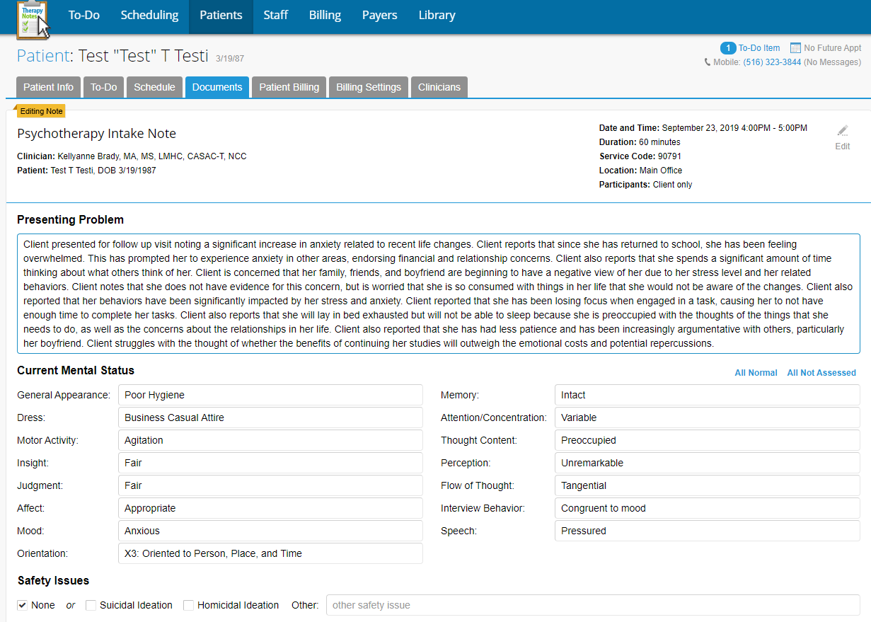

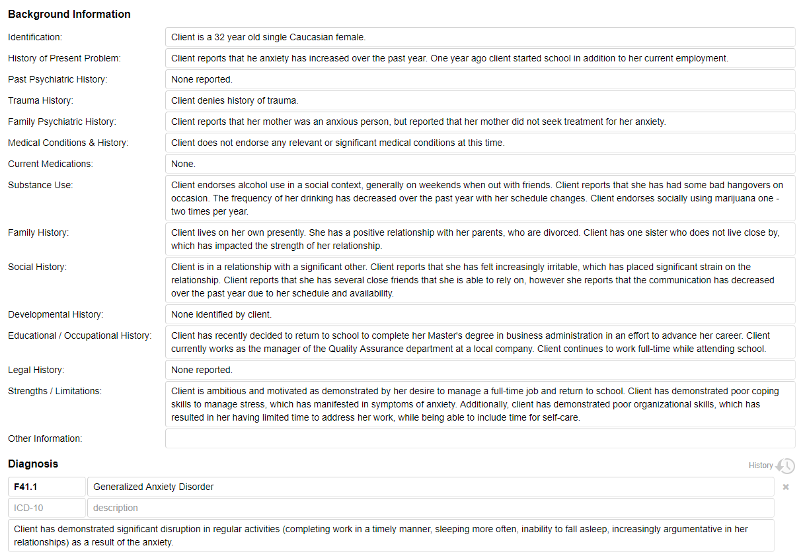
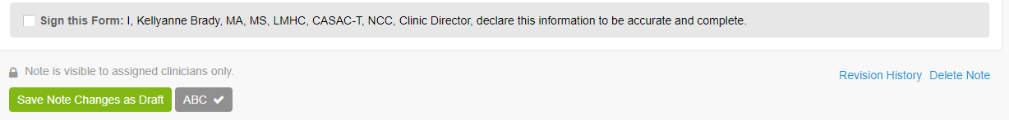
**Always sign the note, spell check, and save the note
The final version will look like this:
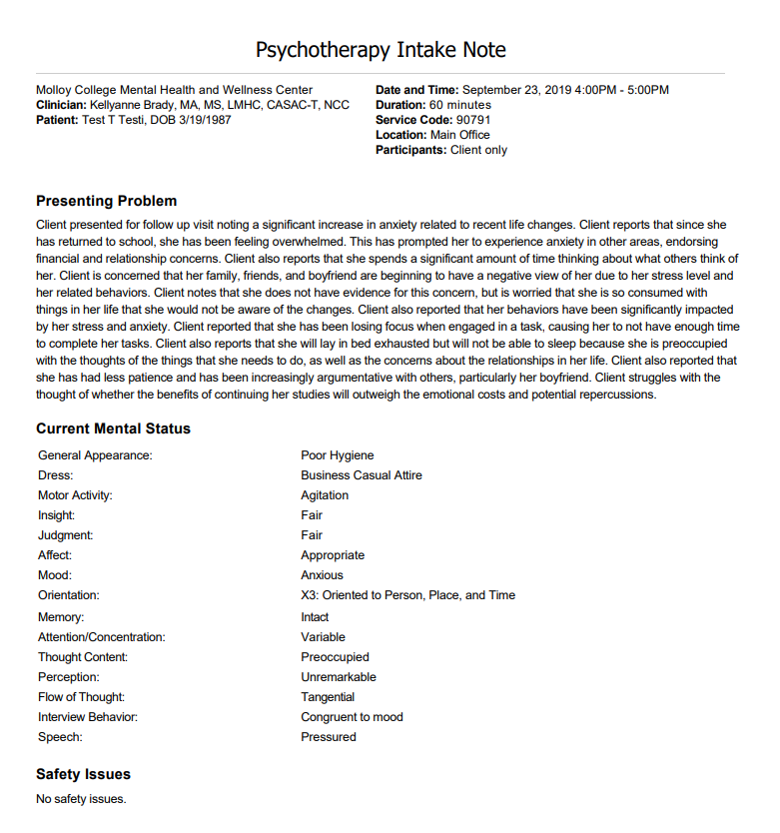
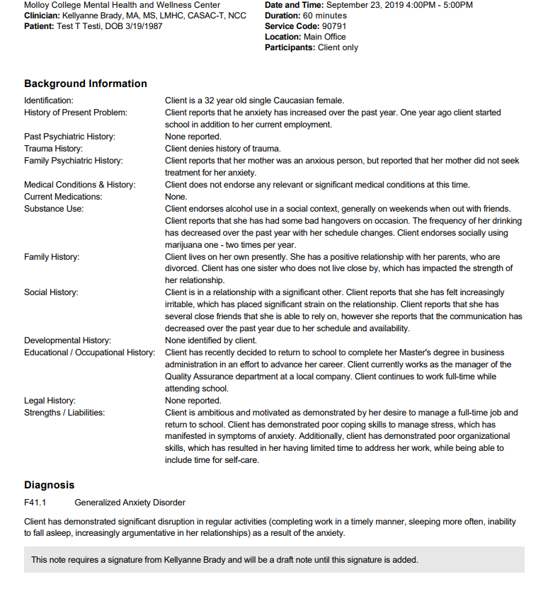
Psychotherapy Treatment Plan:
Now you will complete the treatment plan. If you complete the intake note first, the following information will populate automatically for you:
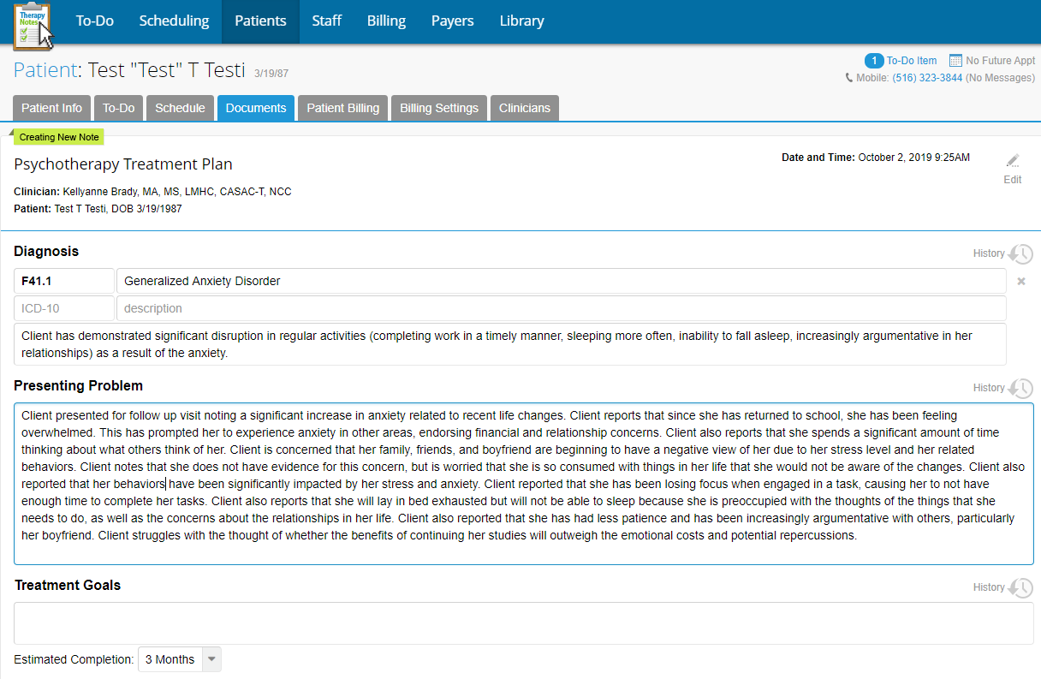
Now, all you will need to do on here is create goals and objectives.
Treatment goals are broader goals for the patient and objectives are more specific and give direction to the goals that are set. In this note, I have created two goals for the client, each goal is connected to an objective, as you can see with the arrows.
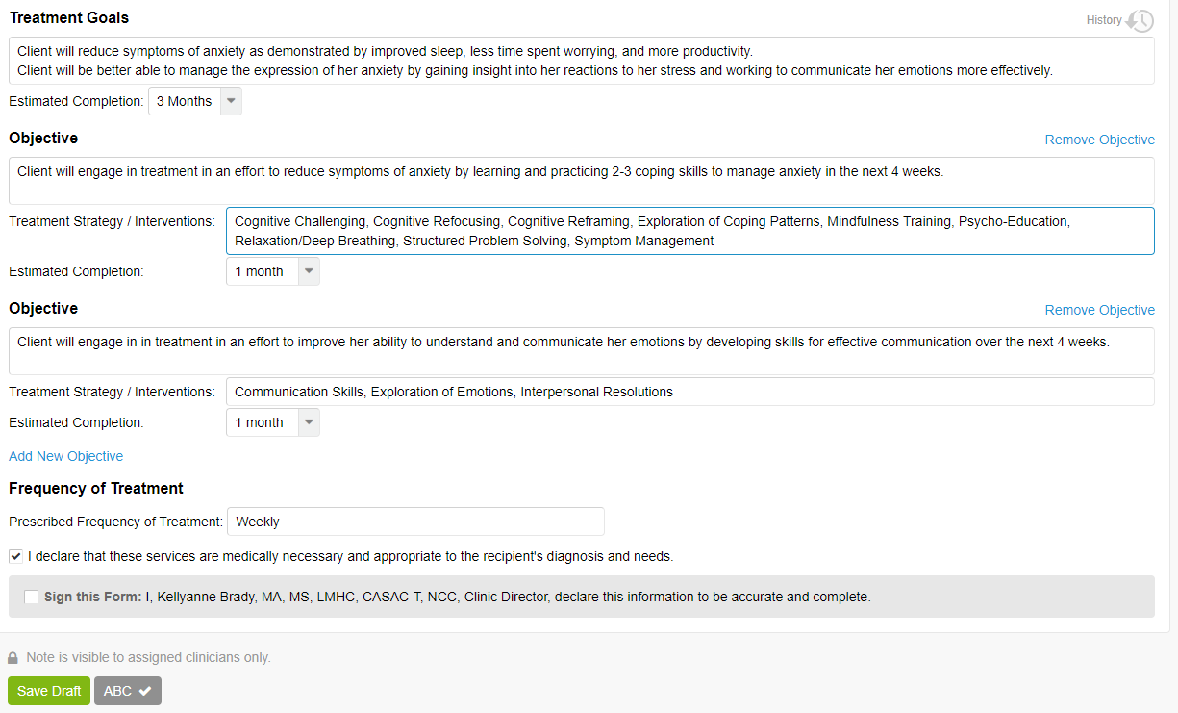
**Always sign the note, spell check, and save the note
The final version will look like:
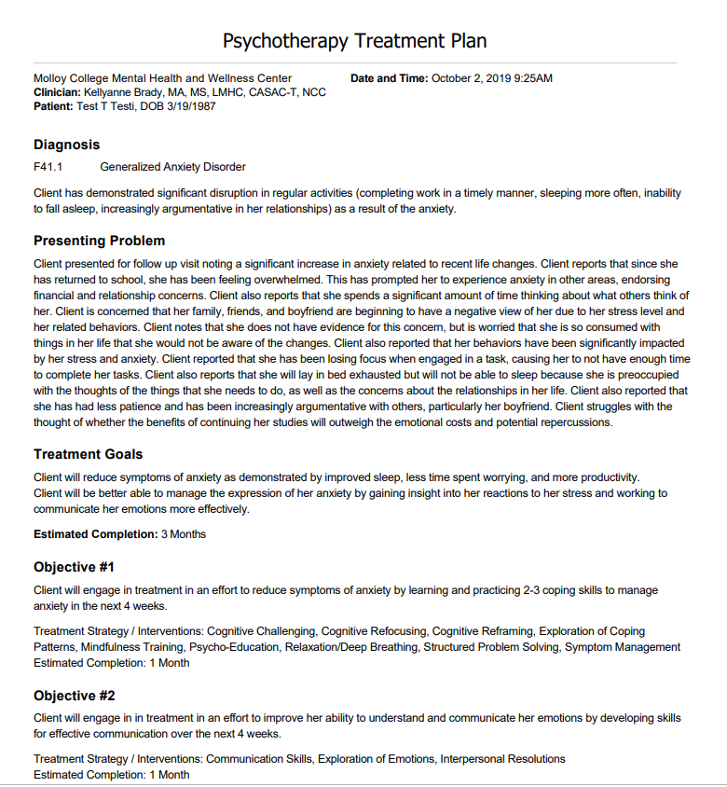
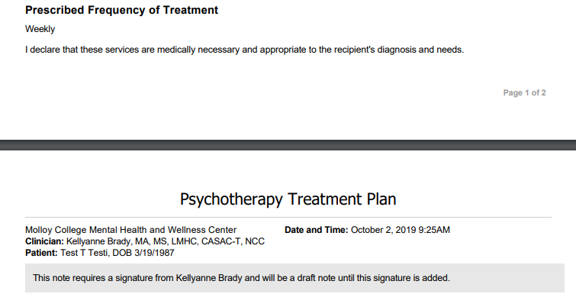
Progress Notes:
Follow up visits will require only the progress note to be complete. One exception to this will be when the goals for the client change (i.e. if the client achieved the goal, a new goal is discussed). If this happens, the treatment plan will need to be updated by going to patient documents and selecting the treatment plan.
When the new note is created, this will populate for you:
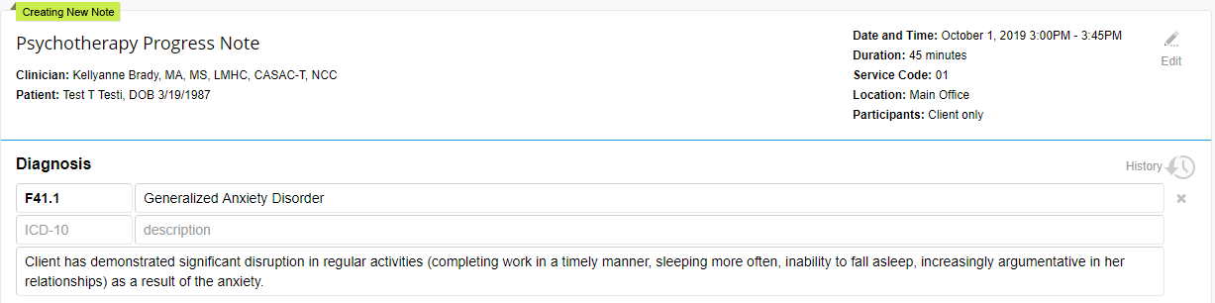
You can make changes to it if appropriate, and the treatment plan should be adjusted accordingly.
These are drop down boxes where you need to make the accurate selection based upon the client’s presentation in the session (You can also write in your own words, see MSE information provided at orientation):
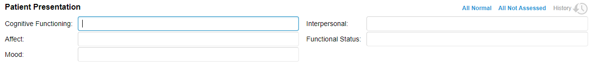
Now you will be able to enter the remainder of the note:
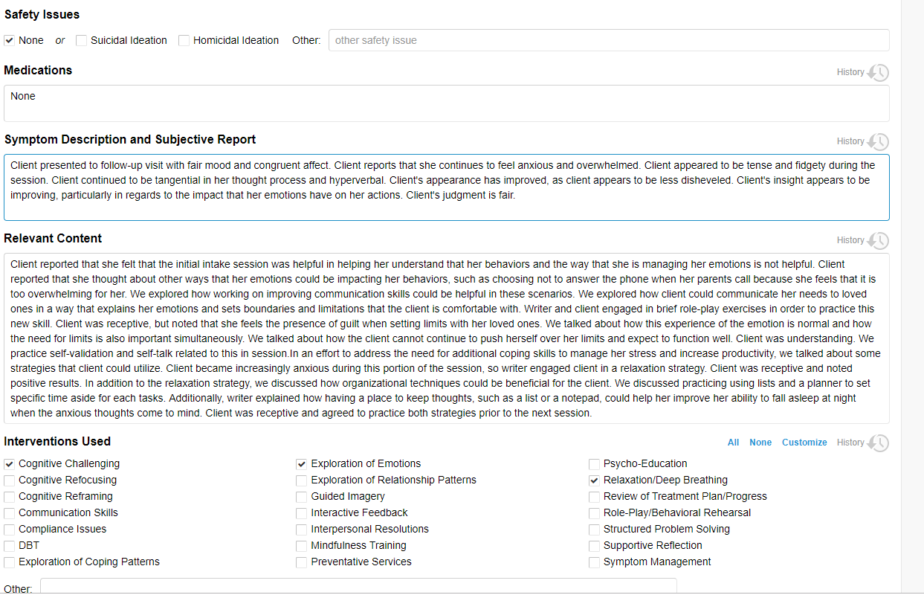
And update progress towards the treatment plan:
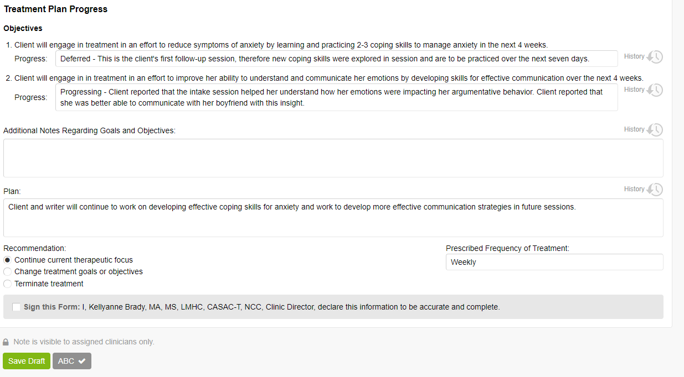
** Remember to spell check before signing and saving!
The final note will look like this:
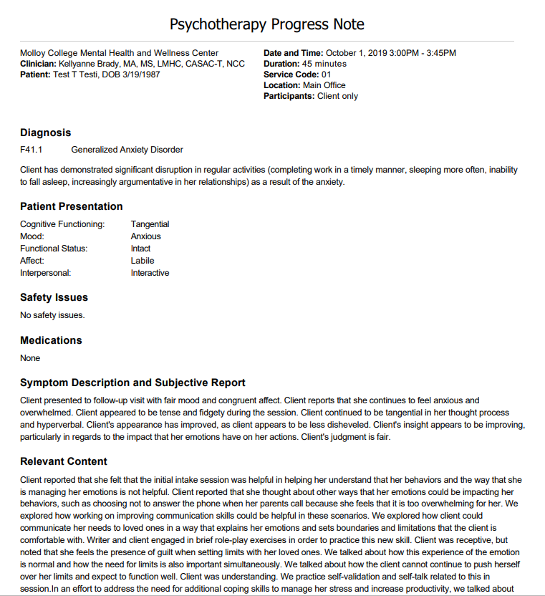
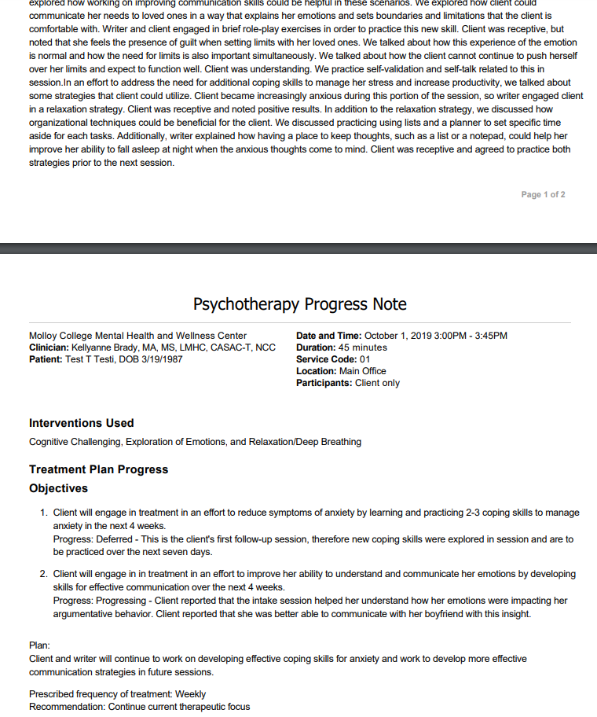

OTHER NOTES
Contact Note
Contact notes should include as much detail as possible so that other clinician are aware of the contact.
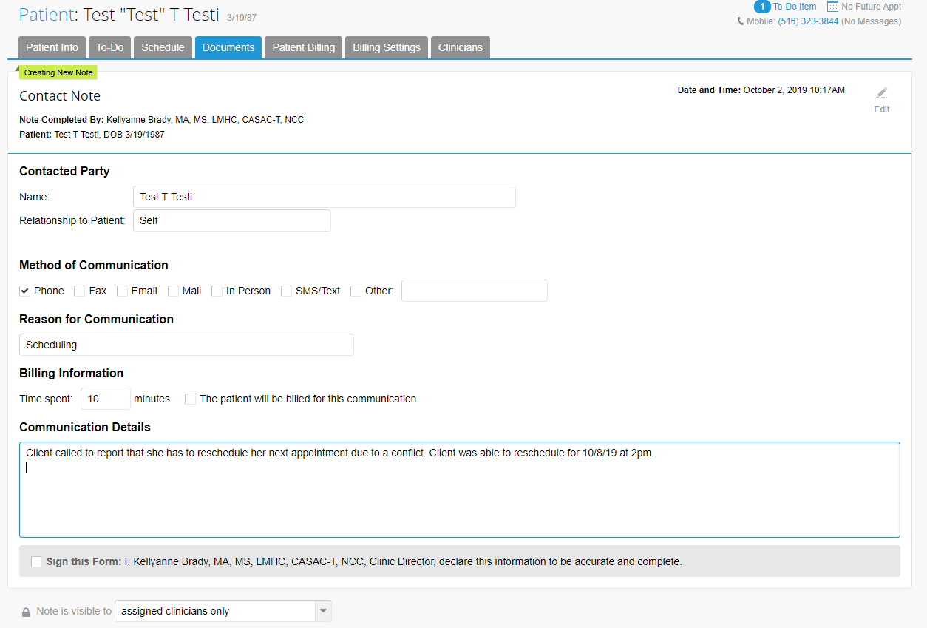

CANCELLATIONS AND NO SHOWS
Cancellations and no-shows (appt missed) can be documented right from the appointment dashboard:
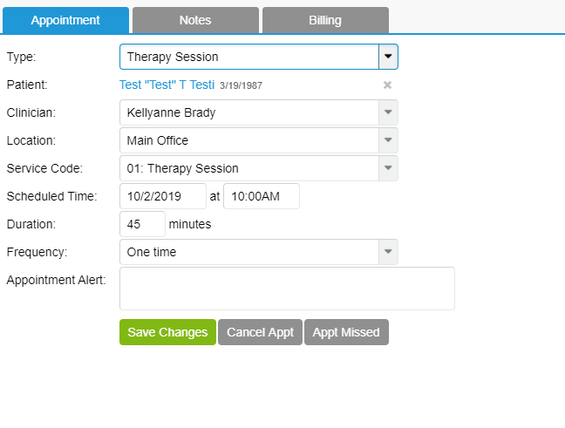
Cancelled appointments within 24 hours of session:
Click on Cancel Appt- the following will appear:
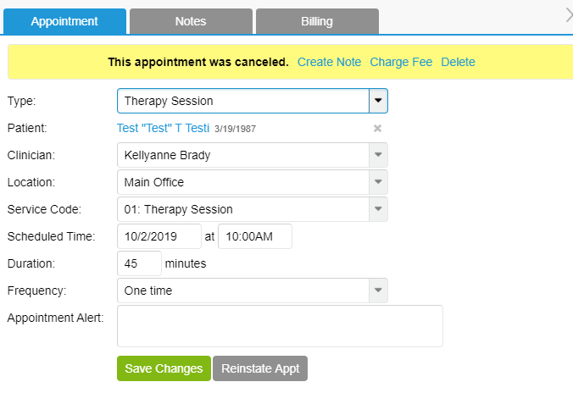
You will need to create a note:
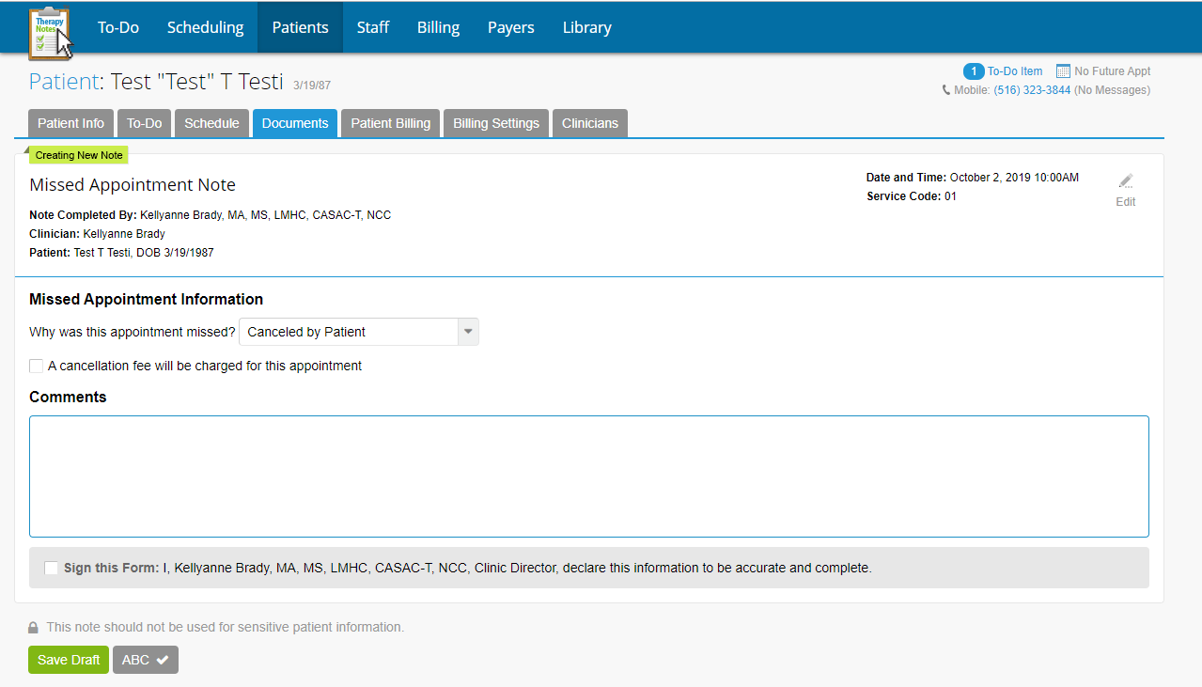
And charge the fee:
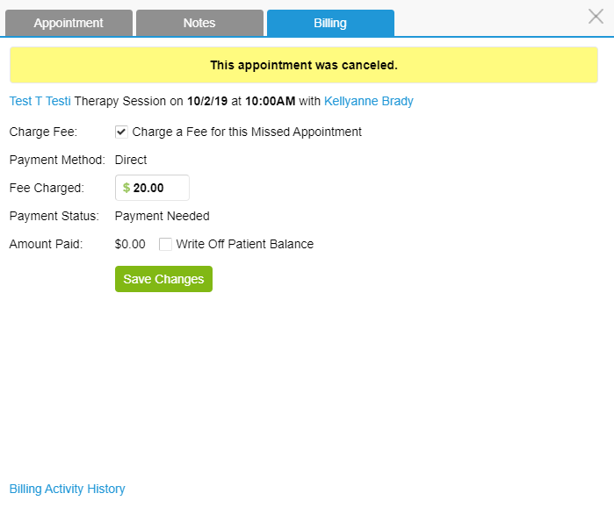
Now $30, or equal to session fee
If the client misses the appointment:
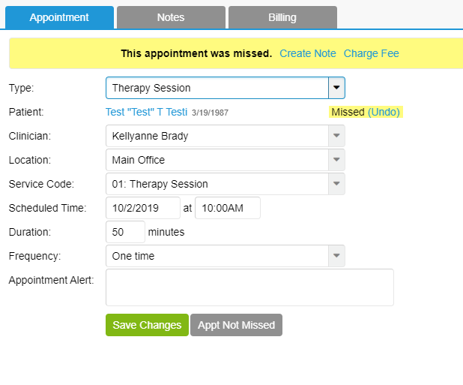
Follow the same process as cancelled appointments when creating a note and charging the fee.

