How to navigate the Molloy University Financial Aid Portal to complete your Terms and Conditions and other functions.

Step 1. Login into your Molloy University portal using your Username and Password
Step 2. Once logged in, please open the tab called My Financial Aid Portal, then scroll down and click on the link.
Step 3. Once in your portal, check the top right corner to confirm what academic year you would like to view.
Step 4. Next, select the Menu button located on the top left corner. The following steps are to be done in order starting from the top to the bottom.
Step 5. Please click on Financial Aid Disclosure. Review the information carefully as it is a breakdown of your estimated tuition, fees, cost of attendance and your aid for the selected Academic year.
Step 6. Next click on the *FERPA Agreement, complete the two fillable fields. Once done Click Save and Submit.
*Note this agreement allows the Financial Aid Office to disclose financial information about your account to a third-party (ie: Parent(s)/Guardians).
Step 7. Next Review your Financial Aid Offer, this tab further breakdowns your aid giving you the estimated amounts for the academic year.
Step 8. After you have reviewed your Aid click on the tab Accepting your Financial aid offer(s). Please read and then select I agree to these Terms and Conditions then click submit.
Step 9. After submitting your Terms and Conditions you will be able to view all your aid being offered. Please review all aid and then either Accept, Decline, or Reduce. Once all aid is no longer in pending status, please click submit. * Note if any aid Status is still pending this form is considered incomplete.
Step 10. Lastly select Documents and Messages to review any missing documents the office still requires from you. To access your missing document please click on the document name. Also all documents are available on our website in PDFs: https://www.molloy.edu/admissions-aid/financial-aid/printable-forms or via the Forms and Links tab in the Menu dropdown on the top left-hand corner. *Note always check the Academic year before filling out any forms.

See Below the Step-by-Step Guide with Images on how to navigate the Molloy University Financial Aid Portal

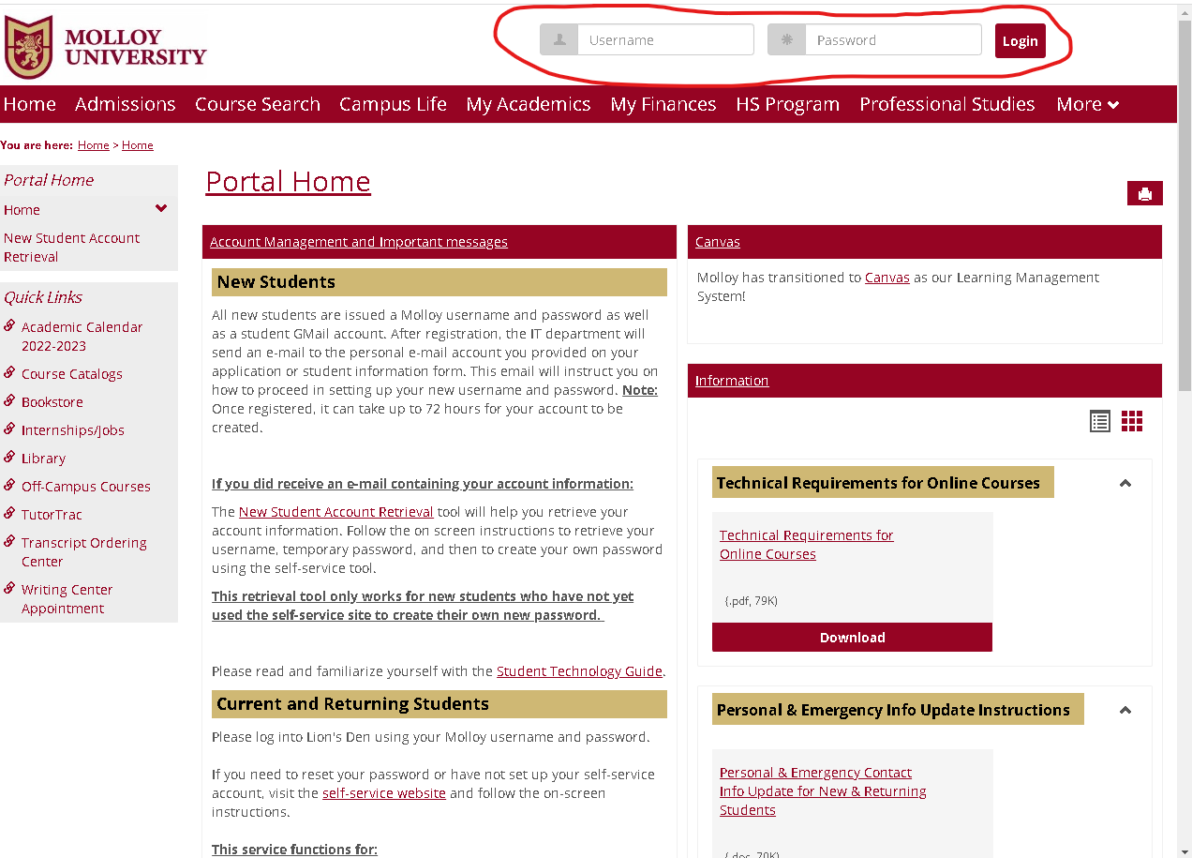
Step 1. Login into your Molloy University portal using your Username and Password

Step 2. Once logged in please open the tab called My Financial Aid Portal, then scroll down and click on the link.
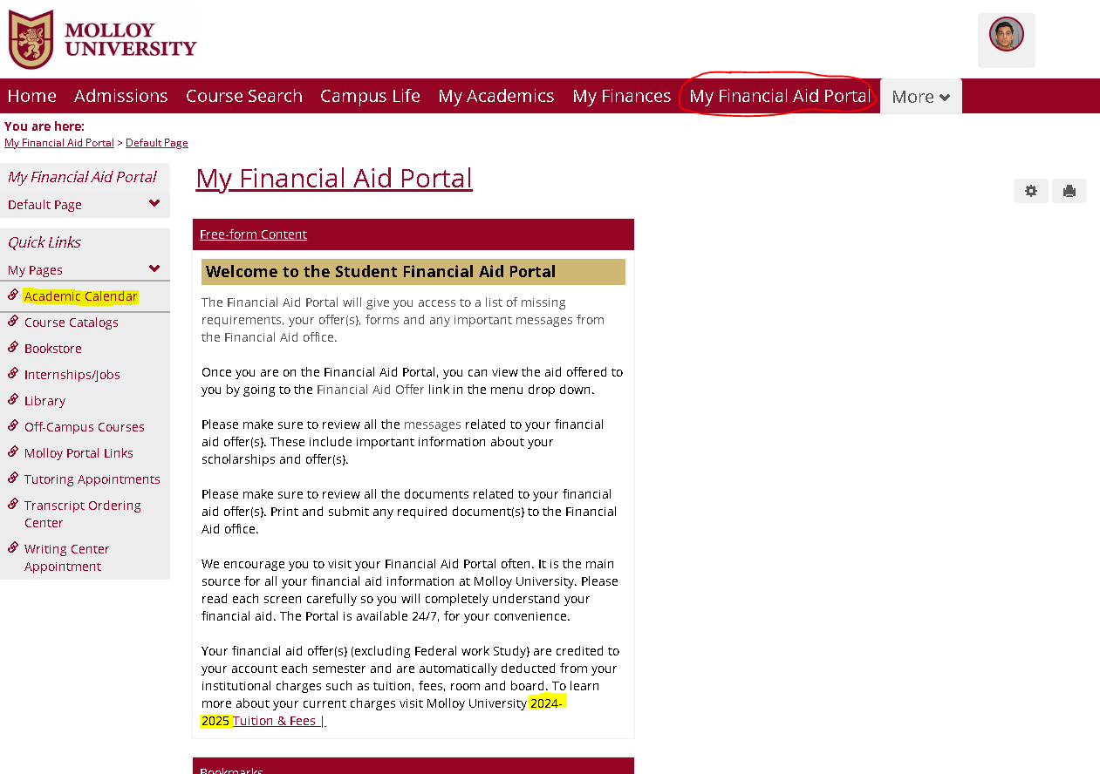

Step 3. After confirming the year select the Menu button located on the top right corner. The following steps are to be done in order starting from the top to the bottom.
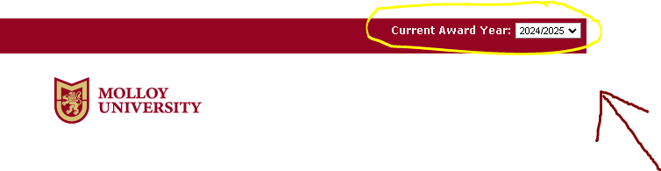

Step 4. After confirming the year select the Menu button located on the top left corner. The following steps are to be done in order starting from the top to the bottom.

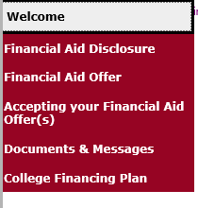

Step 5. Please click on Financial Aid Disclosure. Review the information carefully as it breakdowns your estimated tuition, and your aid for the selected Academic year.
Step 6. Next click on the *FERPA Agreement, complete the two fillable fields. Once done Click Save and Submit.
*Note this agreement allows the Financial aid office to disclose financial information about your account to a third-party (ie: Parent(s)/Guardians).
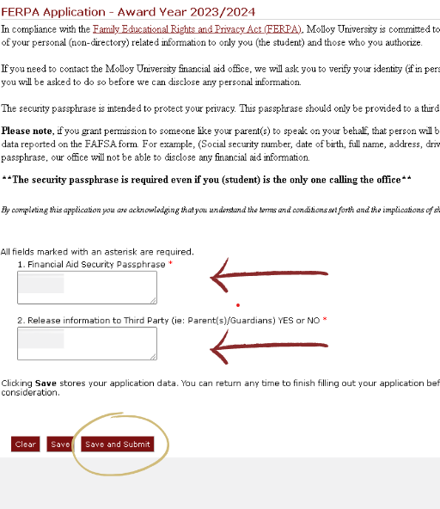

Step 7. Next Review your Financial Aid Offer, this tab further breakdowns your aid giving you estimated amounts for the academic year.
Step 8. After you have reviewed your Aid click on the tab Accepting your Financial aid offer(s). Please read and then select I agree to these Terms and Conditions then click submit.
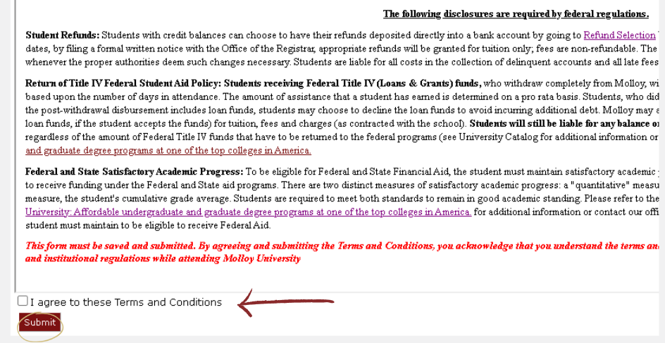

Step 9. After submitting your Terms and Conditions you will be able to view all your aid being offered. Please review all aid then either Accept, Decline, or Reduce. Once all aid is no longer in pending status, please click submit. *Note if any aid status is still Pending this form is considered Incomplete.
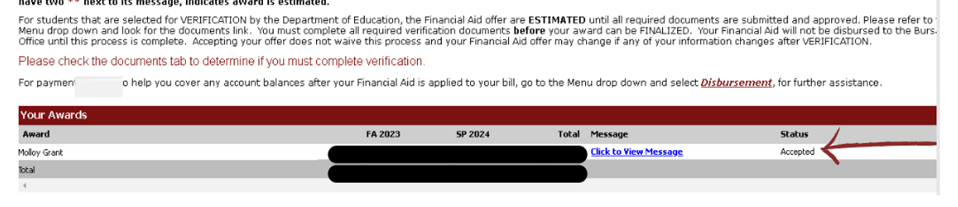

Step 10. Lastly select Documents and Messages to review any missing documents the office still requires from you. To access your missing document please click on the document name. Also all documents are available on our website in PDFs: https://www.molloy.edu/admissions-aid/financial-aid/printable-forms. Or via the Forms and Links tab in the Menu dropdown on the top left-hand corner. *Note always check the Academic year before filling out any forms.

